Introduction to Data Analytics AT3

Contents

Data Mining Problem 2

Data Preprocessing and Transformations 3

Rank Correlation and Column Filtering 3

Number to String 5

Missing Values 6

Numeric Outliers 7

Normalisation 9

Category to Number 9

Solving the Problem 10

Classification Techniques and Parameter Settings 15

Decision Trees 15

Model 1 16

Model 2 18

Model 3 20

Model 4 22

K-Nearest Neighbour 24

Random Forest (Ensemble Method) 26

Model 1 27

Model 2 29

Model 3 31

Support Vector Machine 33

Multi-Layer Perceptron (Neural Network) 36

Gradient Boosted Trees Learner (Ensemble Method) 39

K Fold Cross Validation on KNN 42

Selected Classifier 45

Kaggle Submission Score 45

Summary 45

Appendix 46

# Data Mining Problem

The Data mining problems is the hospital’s inability to predict patients who will or will not expire. The consulting firm has been given 3 datasets:

1. A Healthcare-Dataset.csv which is will be used as the training data to build and optimise the model (it contains the target value ExpiredHospital)
2. An Unknown-Dataset.csv for the final model assessment which does not contain the target values, hence we must predict them.
3. A Kaggle-Submission-Random-Sample.csv file which outlines the format required for the output of the final model. The output should be in the form of a two column table with the first column for the “row ID” and second column for the “Predicted-ExpiredHospital” values.

This is a classification task where the goal is to classify the “ExpiredHospital” attribute with 0 if it is not expired and 1 for expired. We are expected to create the most accurate model using the input attributes and their known ExpiredHospital values. After the classifier has been created we are to apply the classifier to the unknown data set and submit the results in the format of the sample dataset to Kaggle. The input attributes are summarised in Table 1.

|  |  |  |  |
| --- | --- | --- | --- |
|  | **Attribute Name** | **Attribute Type** | **Description** |
| 1 | gender | String | Gender of the patient (e.g., Male or Female). |
| 2 | age | Integer | Age of the patient. |
| 3 | LOSdays | Integer | Length of Stay in days. |
| 4 | admit_type | Integer | Type of admission (e.g., EMERGENCY, ELECTIVE). |
| 5 | admit_location | String | Location from which the patient was admitted. |
| 6 | AdmitDiagnosis | String | Diagnosis upon admission. |
| 7 | Insurance | Integer | Type of insurance the patient has. |
| 8 | religion | String | Patient's religion. |
| 9 | marital_status | String | Marital status of the patient. |
| 10 | ethnicity | String | Ethnic background of the patient. |
| 11 | NumCallouts | Integer | Number of callouts. |
| 12 | NumDiagnosis | Integer | Number of diagnoses. |
| 13 | NumProcs | Integer | Number of procedures. |
| 14 | AdmitProcedure | String | Procedure upon admission. |
| 15 | NumCPTevents | Integer | Number of CPT events. |
| 16 | NumInput | Integer | Number of inputs. In a hospital or medical context, "input" typically refers to the amount of fluids, medications, or nutrients given to a patient. |
| 17 | NumLabs | Integer | Number of lab tests. |
| 18 | NumMicroLabs | Integer | Number of microbiology labs. |
| 19 | NumNotes | Integer | Number of notes. |
| 20 | NumOutput | Integer | Number of outputs. |
| 21 | NumRx | Integer | Number of prescriptions. |
| 22 | NumProcEvents | Integer | Number of procedure events. |
| 23 | NumTransfers | Integer | Number of transfers. |
| 24 | NumChartEvents | Integer | Number of chart events. |
| 25 | ExpiredHospital | Integer | Indicates if the patient expired in the hospital (0 for No, 1 for Yes). |
| 26 | TotalNumInteract | Integer | Total number of interactions. |
| 27 | LOSgroupNum | Integer | Group number based on the length of stay. |

*Table 1 Input Attributes*

# Data Preprocessing and Transformations

Preprocessing in conjunction with data exploration was used to clean the data which enabled more accurate and robust models to be developed. The preprocessing workflow is outlined in Image 1.

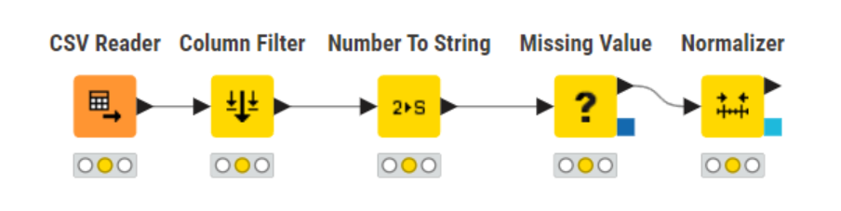

*Image 1 Preprocessing*

## Rank Correlation and Column Filtering

Rank correlation charts illustrate the correlations between attributes in a matrix. Missing values were filled in to avoid filtering of attributes with null values in the rank correlation. We use the rank correlation node to achieve this, and the output is illustrated in Image 2. From this we find that only age, admit_type, Num_Callouts, NumDiagnosis, NumProcs, NumCPTEvents, NumInput, NumLabs, NumMicroLabs, NumNotes, NumOutput, NumRx, NumTransfers, NumChartEvents, and TotalNumINteract are the attributes with tangible predictive power. Hence, we remove all other attributes using the column filter node as shown in Image 10 to remove noise from the training data which affects the accuracy of the models.

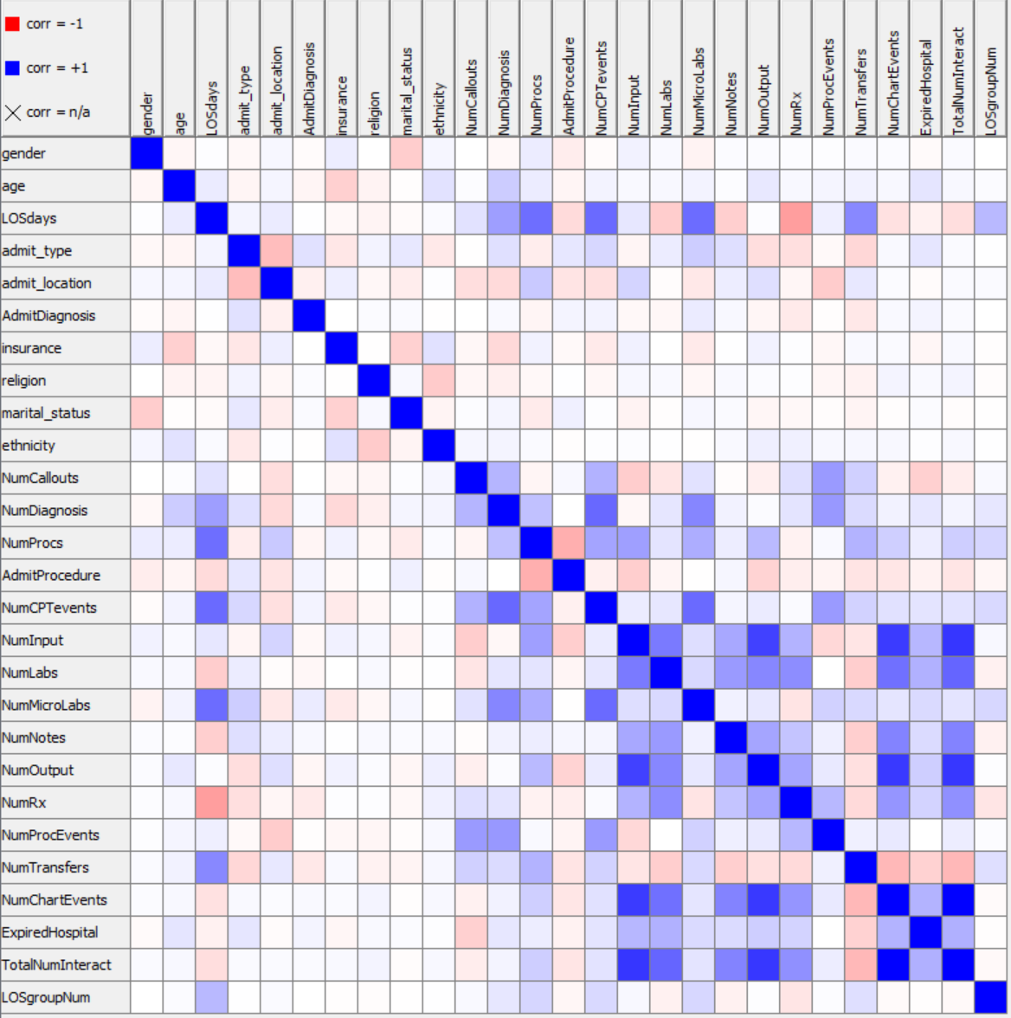

Image 2 Rank Correlation

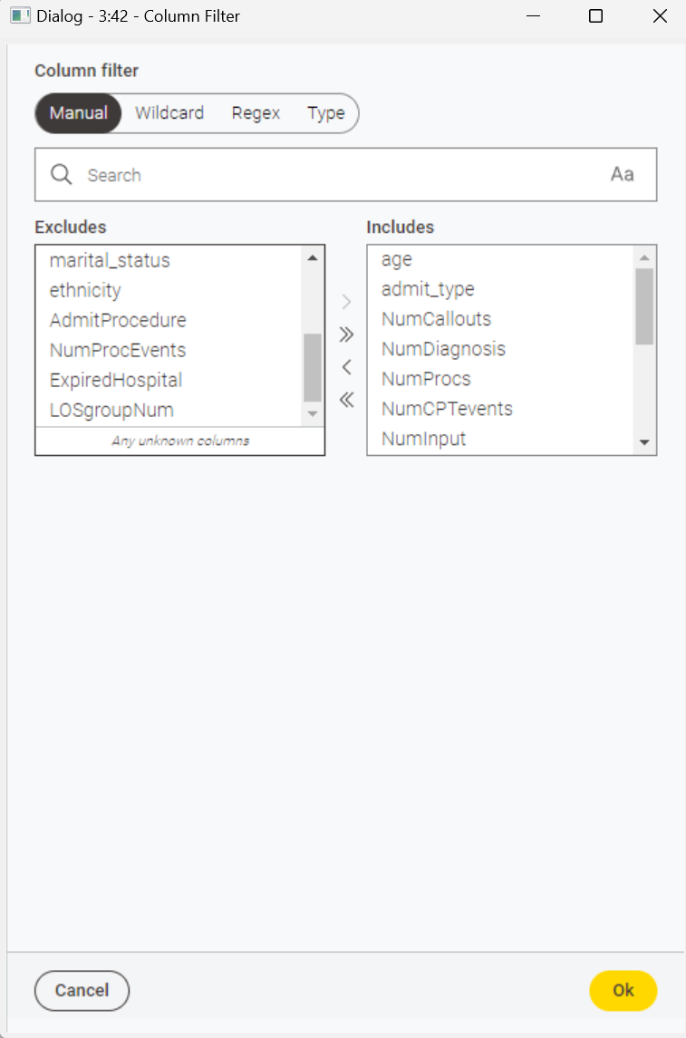

Image 3 Column Filter

## Number to String

We convert the target attribute ExpiredHospital from numbers (0 or 1) to strings (“0” or “1”). This enables the models to target the attribute for classification by providing a format that can be considered categorical rather than numerical. This is achieved with the number to string node as outlined in Image 6.

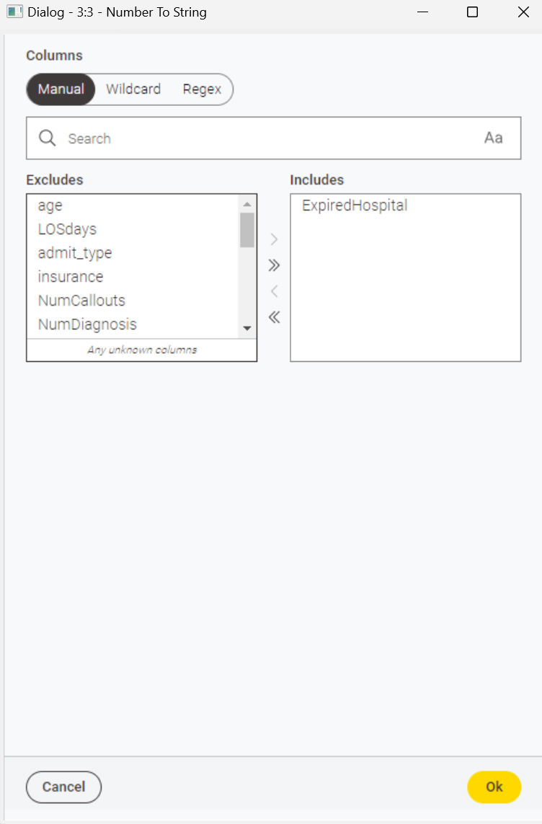

*Image 4 Number to String*

## Missing Values

Missing values from failed recording can affect the training of categorisation models by not providing sufficient data to extract trends. Table 2 shows the attributes with a non-negligible (>= %5) number of missing values. We place the missing value node before any category to number nodes to avoid taking the average of categorical data when filling in missing values.

|  |  |
| --- | --- |
| **Attribute** | **% of rows without data** |
| age | 5.0% |
| marital_status | 17.3% |
| NumCallouts | 5.0% |
| LOSgroupNum | 90.0% |

*Table 2 Missing values*

To address this first we remove the LOSgroupNum attribute as more than half of the rows are missing this for attribute. This creates a robust model without removing the rows with missing data which would lose a lot of information for training. This is achieved with the column filter node with the settings in Image 5.

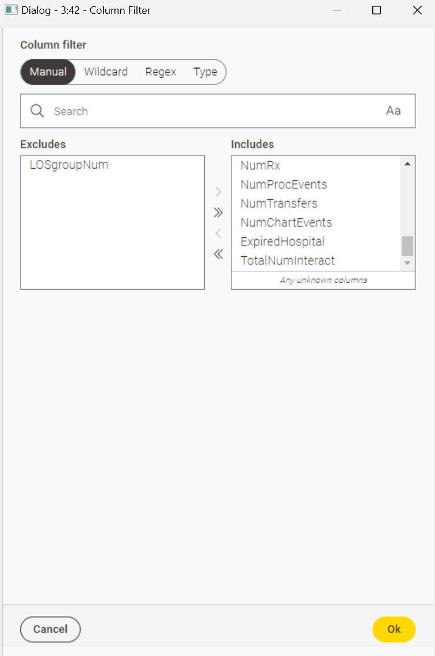

*Image 5 Column Filter*

For the remaining missing values, we fill them in using the missing value node with the settings in Image 6. We chose to do nothing with missing data of type String as there is no average value that can be used, and selecting the most frequent value can introduce invalid trends when there are other reasons for the recordings not being included in the data. We filled in numeric attributes with the median to avoid the influence of outliers. This also ensured that valuable rows were not lost for training other attributes by removing null rows. We found these settings to follow industry best practices and produce the most accurate models.

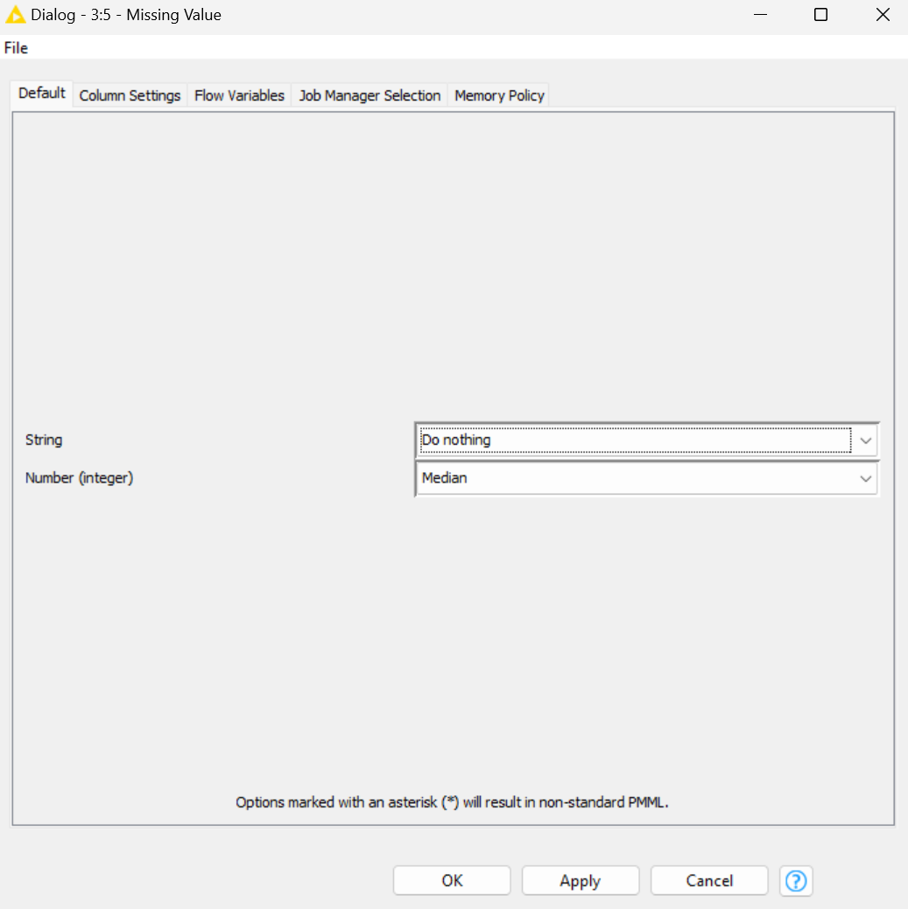

*Image 6 Missing Value*

## Numeric Outliers

We checked the data for extreme outliers which can clead to overfitting of models when trained on this data, notably, TotalNumInteract (See Image 7). We initially applied the Numeric Outlier node with settings outlined in Image 8 to remove these rows. We categorised outliers using the interquartile range multiplier of 1.5 which is standard industry practice and maximises model accuracy. However, the rank correlation analysis found this attribute to not be needed so this preprocessing step was ultimately not necessary.

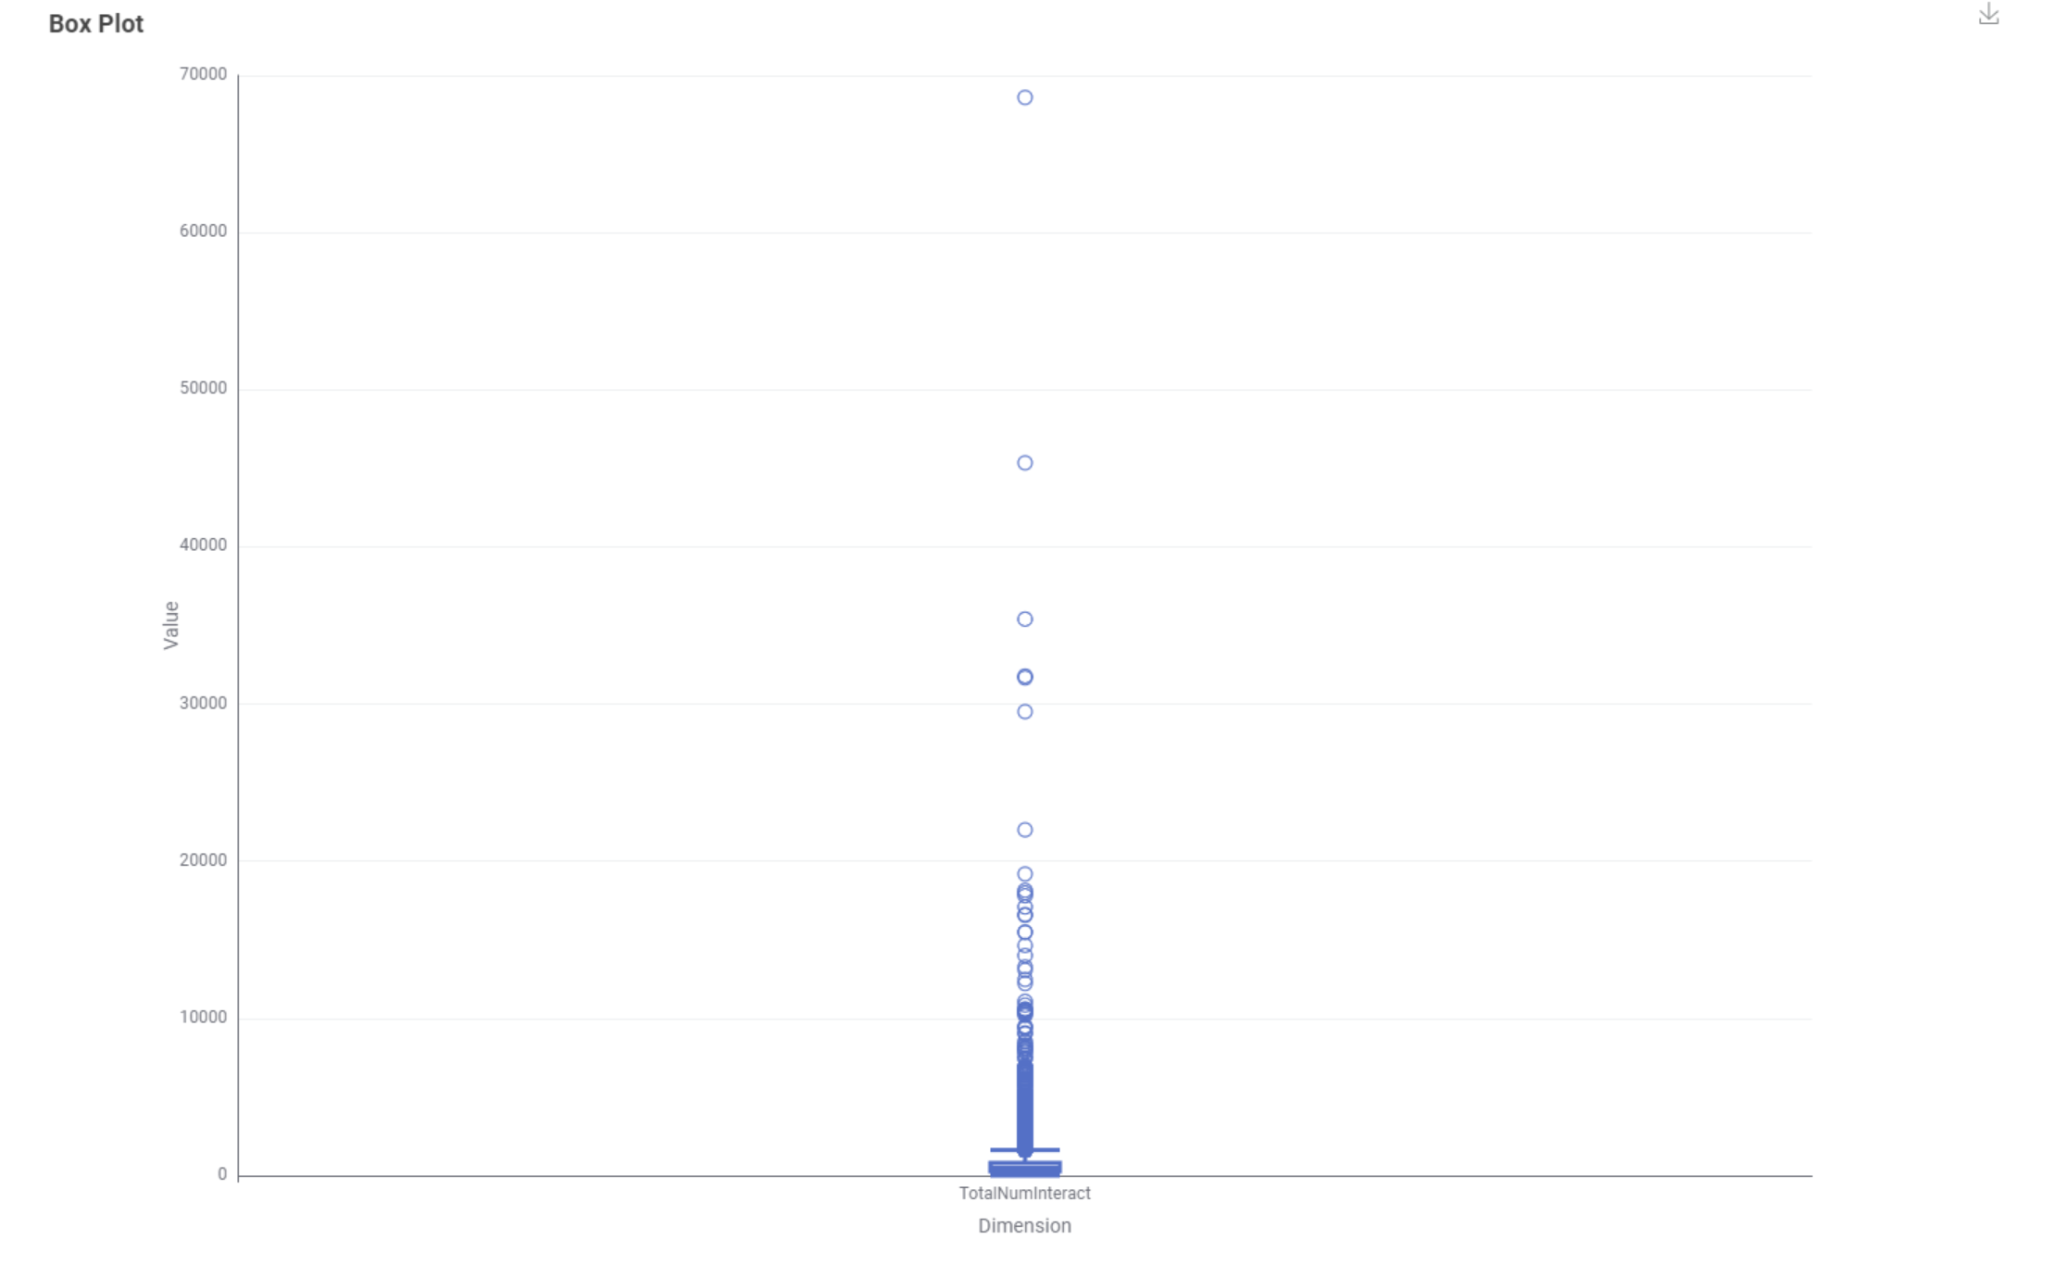

*Image 7 TotalNumInteract Box Plot*

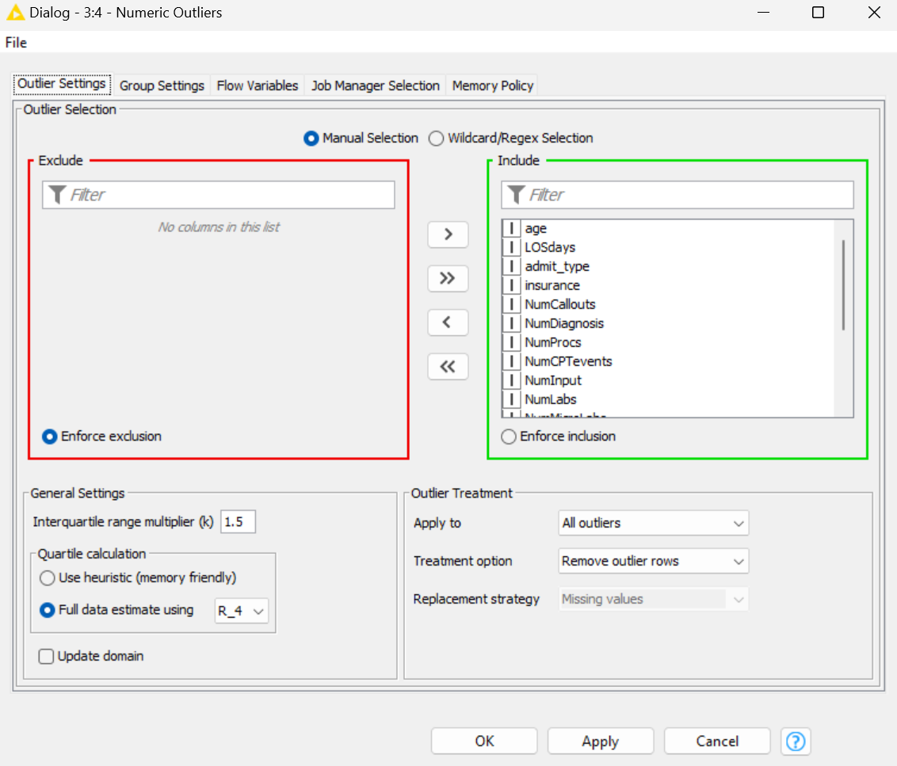

*Image 8 Numeric Outliers*

## Normalisation

Attribute normalisation is the process of taking values that span a given range and representing them in a different range (Typically -1 to +1, or 0 to 1). This crates a common scale for numeric values. The goal of normalisation is to ensure information and the relative distribution between data points are not lost in this process. We normalise the data to enable training of SVM and NN models. We use the normalizer node with the settings outlined in image 9 to achieve this. We select Z-Score normalization as it provides the best results given that outliers are not present, which we have already removed in previous preprocessing.

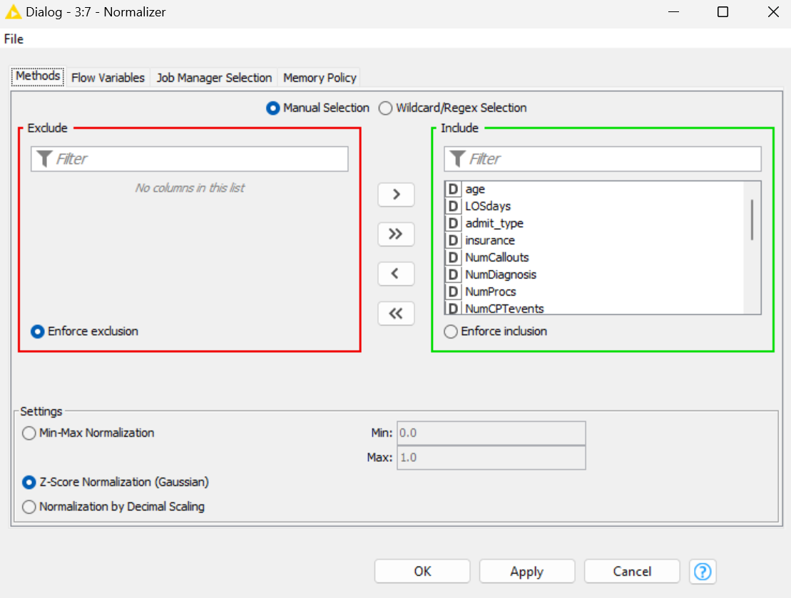

*Image 9 Normalizer*

## Category to Number

Initially, we converted categorical attributes in the forms of strings to numerical values to enable training of the MLP on these attributes as MLPs can only be trained on numerical values. We achieve this using the Category to Number node shown in Image 10. We set the max categories to a high number, 100000, to ensure all categories are captured by a number as some attributes have many categories. We keep ExpiredHosptial as a string as this is the correct data type for classifiers to recognise it as the target attribute. However, we found that if we applied this node after rank correlation analysis and column filtering it would be redundant, so we removed it, as there was no categorical data remaining.

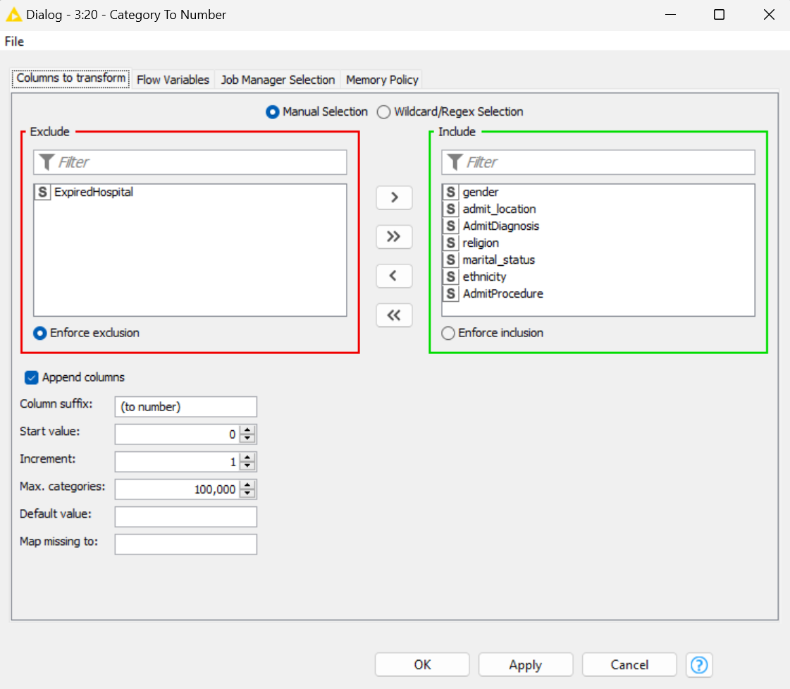

Image 10 Category to Number

# Solving the Problem

To solve the problem various techniques were applied to optimise the classifiers. Feature selection was applied in preprocessing to remove attributes which did not tangibly correlate to the target feature. Hence, if these features were left in, they would only add noise that would interfere with the accuracy of the model.

Parameter optimisation was used were manual trial and error was too tedious. This was achieved with the “Parameter Optimisaiton Loop Start” (See Image 11) and “Parameter Optimisation Loop End” (Seem image 12) nodes. From these nodes we can configure the desired parameters of the classifiers to automatically optimise within a range, with respect to a given accuracy measurement. The “Parameter Optimisation Loop Start” node is where we define the attributes to optimise, the range in which to optimise them, the step size between range values and the maximisation technique. We used a brute force approach due to the availability in computing power and because it guarantees finding the optimal value. Small step sizes and large ranges were used to ensure we find the optimal value (For example, See Image 13). We then use the defined attributes from the Loop Start node in the “Flow Variables” of the classifier node after connecting it to the classifier node. The “Paramter Optimisation Loop End” is where we define the accuracy measurement, we want to maximise with our parameter selection. We chose “Accuracy” after connecting it to the Scorer node.



*Image 11 Loop Start*

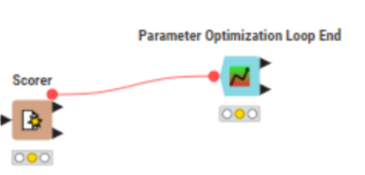

*Image 12 Loop End*

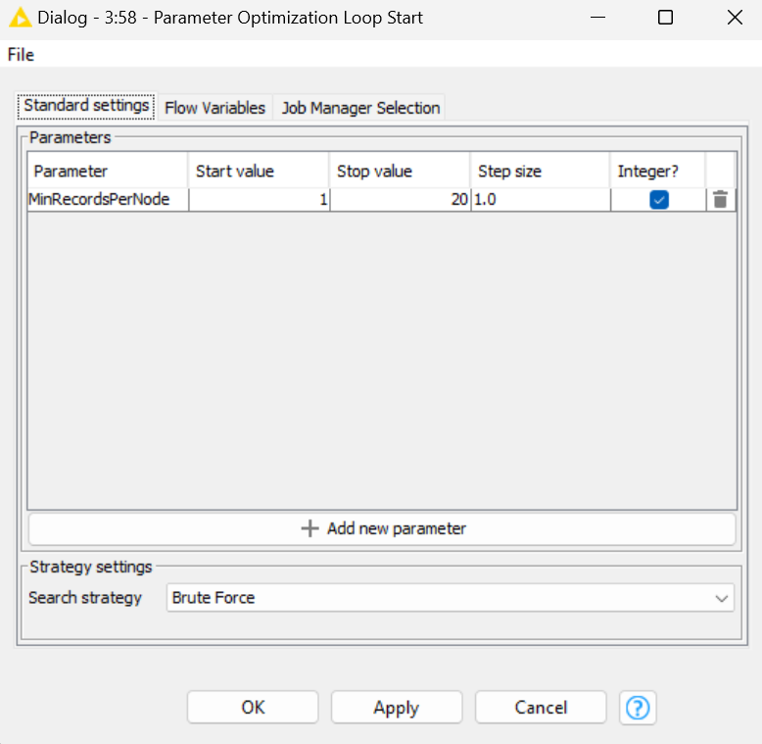

*Image 13 Loop Start Settings*

We partitioned the data in two ways for the classifier models. Firstly, an industry standard 70/30 split was used for the training and testing data respectively using the “Partitioning” node (See Image 14) with random sampling (See image 15). This ensured that there would be a sufficient amount of both data sets to accurately develop and evaluate the models’ abilities while avoiding long training times. Further, the use of random sampling ensures that trends only present in earlier samples are not learned by the model which would lead to overfitting. Splitting the data up into two sets also ensures that we do not evaluate the model on the same data it was trained on, which can result in the evaluation metrics not noticing overfitting of the classifier. Cross validation was also used in some cases where it was expected to be beneficial. This splits the data up into N partitions and then trains a model on each partition and compares them to avoid overfitting and increase accuracy. We send the training data output into the learner node of a given model, and the test data set into the predictor node of a given model, with the predictor node set to output the class probabilities for later evaluation. We also ensured to not re-run the partitioning node between tests for a consistent data set for fair comparison between models. If we did not do this, random more favourable sampling of the data set could influence the accuracy of models which would affect evaluation metrics.

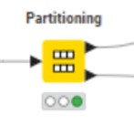

*Image 14 Partitioning Node*

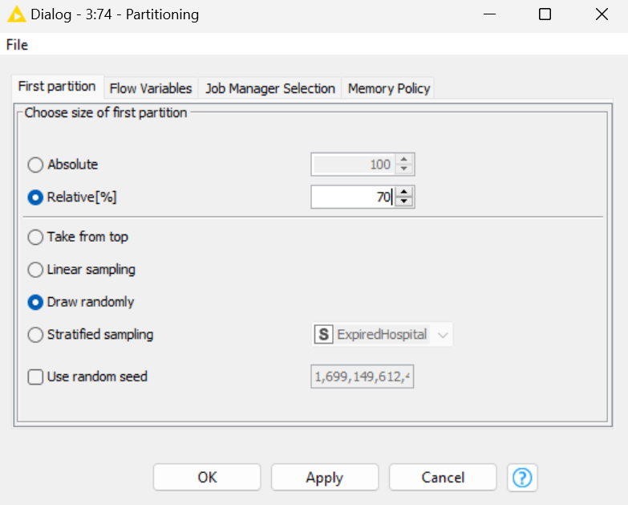

*Image 15 Partitioning Settings*

We evaluated each model using the scorer node (Image 16) and ROC Curves (Image 18). The scorer node gives us a confusion matrix which visualises the False Positive, True Positive, False Negative and True Positive values of the model. It also provides accuracy, recall, precision, sensitivity, specificity, F-measure and Cohen’s kappa scores. We set the first column of the scorer to the target column i.e. “Expired Hospital” and the second column in the scorer to the predicted values of the classifier (Image 17). However, we primarily used the ROC curve to evaluate our model in accordance with industry standard as it visualises the previously mentioned metrics and the model’s ability to accurately classify both categories. The AUC (Area under the curve) is what we try to maximise with the ROC curve. The x axis of the ROC curve outlines the False Positive rate, and the Y axis is the True Positive rate, the goal is to have a high True positive rate even at low False positive rates. This means the classifier has a high degree of separability between the two classes and can accurately distinguish between classes. We set the target column to “Expired Hospital”, the positive class value to 1 and the included class to the probability assigned by the model of the predicted “Expired Hospital” attribute value (Image 19).

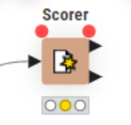

*Image 16 Scorer*

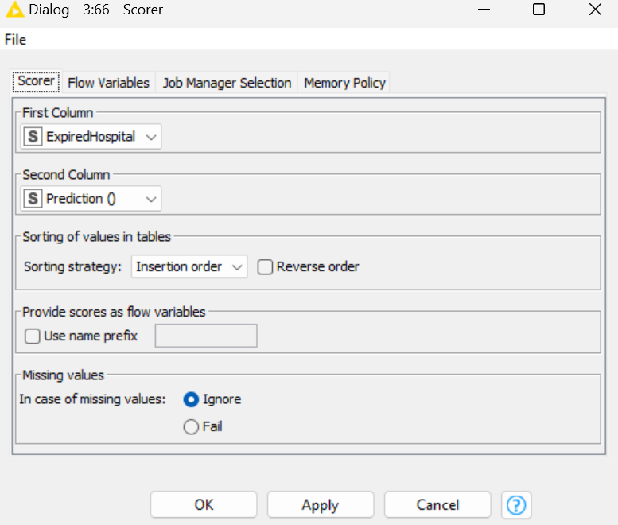

*Image 17 Scorer Settings*

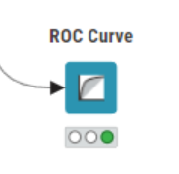

*Image 18 ROC Node*

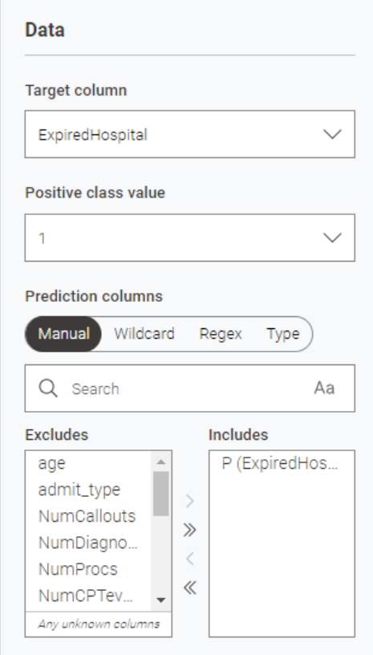

*Image 19 ROC Settings*

When training data has an uneven number of samples for each category, we call this unbalanced data. This can introduce bias where the model achieves a high accuracy only because it is learning to effectively categorise the majority set which is also the majority in the test set. For example, the training data for this problem has approximately 90% of patients not expiring in hospital. Hence, if the model can achieve a 90% accuracy simply by guessing 90% of patients did not expire when categorising from the test set. However, we will find that the false positive of the algorithm will be high. To solve this, we typically would remove bias by introducing more samples from the minority category using the SMOTE node. After testing our models with and without this node we found a negligible or negative impact on performance surprisingly. For example, the AUC of RF decreased by 5%. This node was only applied on the training data and configured in accordance with image 20 but was ultimately not used.

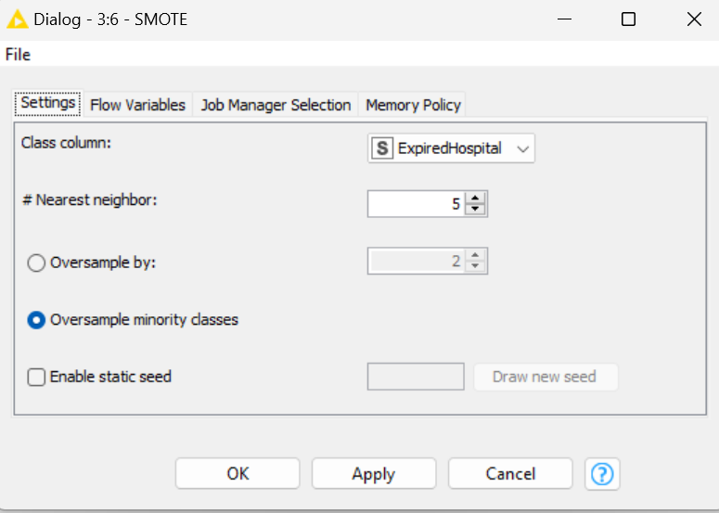

Image 20 SMOTE

# Classification Techniques and Parameter Settings

The next step was to create and evaluate multiple classifiers using the Healthcare dataset.

## Decision Trees

A decision tree is a transparent mechanism that allows us to follow a human understandable tree structure for classification to predict a class label of an unseen instance. It is easy to understand and interpret however it is prone to overfitting if the tree is too complex or if the training data is noisy, however we addressed this with preprocessing. Additionally, missing values affect decision trees by affecting impurity measures. Hence, we have addressed missing values in preprocessing. Further, we converted “Expired Hospital” to a string to enable the use of the “Decision Tree Learner” Node as it requires the target class to be categorical.

We used parameter optimisation to find the that the optimal value for “Min Records Per Node” was 6 in the rang 1 to 20. We then used trial and error with the other configurable values find the best decision tree classifier as outlined in Image 20 and below.

We found that Model 1 with the quality measure set to Gain ratio and no pruning produced the best results. It had an overall higher AUC value than the other model settings, as well performing better overall in the scoring metrics, while Model 2, 3 and 4 shared similar values. The ROC curves are symmetrical indicating an even ability to classify both categories.

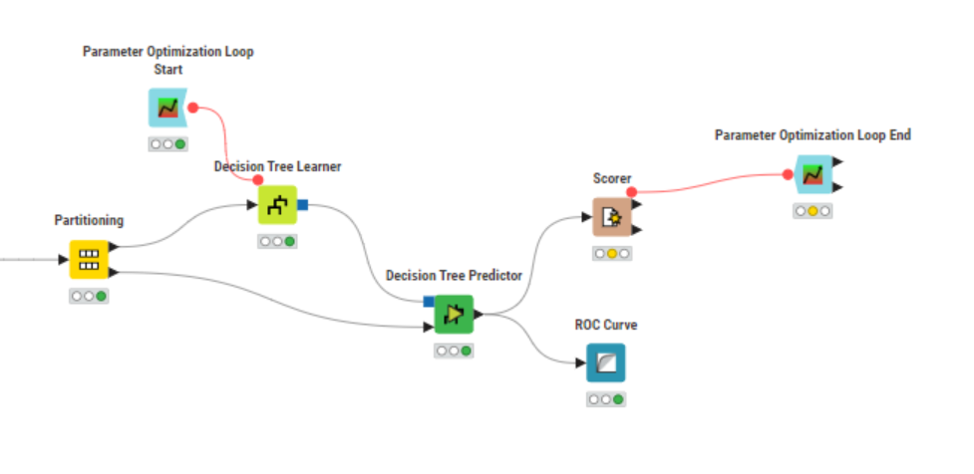

*Image 21 DT Workflow*

### Model 1

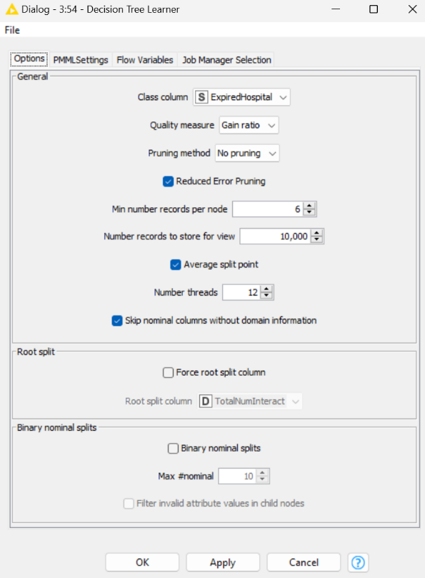

*Image 22 Model 1 Settings*

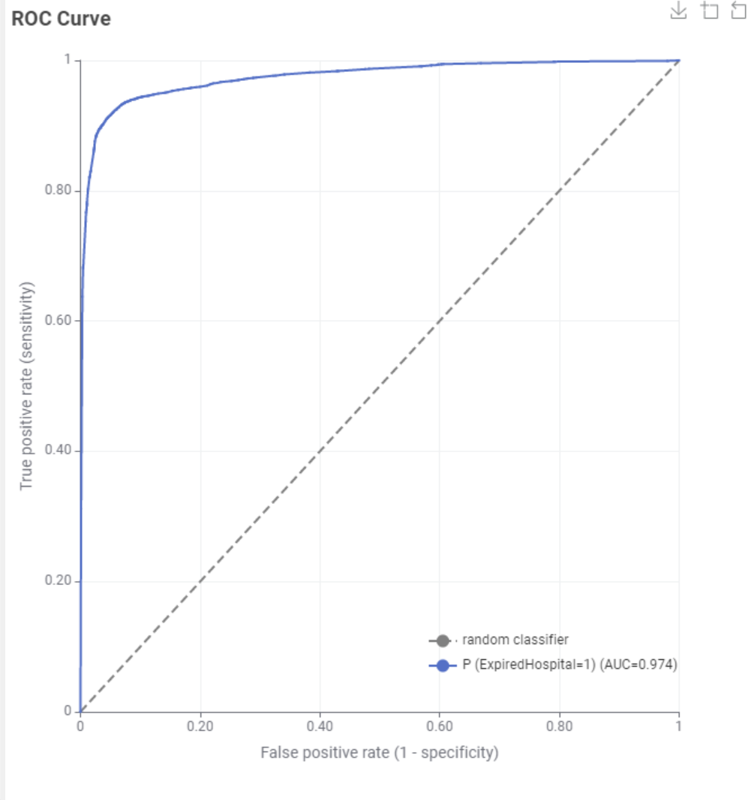

*Image 23 Model 1 ROC*

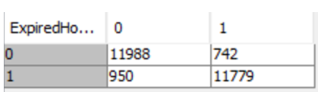

*Image 24 Model 1 Confusion Matrix*

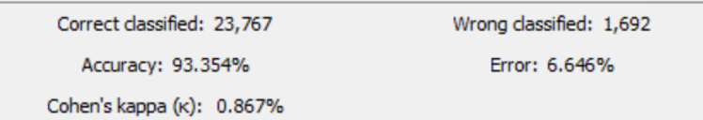

*Image 25 Model 1 Accuracy*



*Image 26 Model 1 Scores*

### Model 2

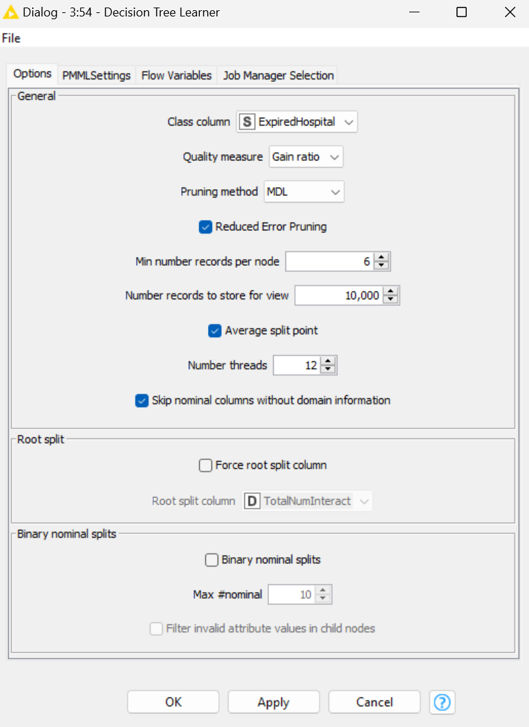

*Image 27 Model 2 Settings*

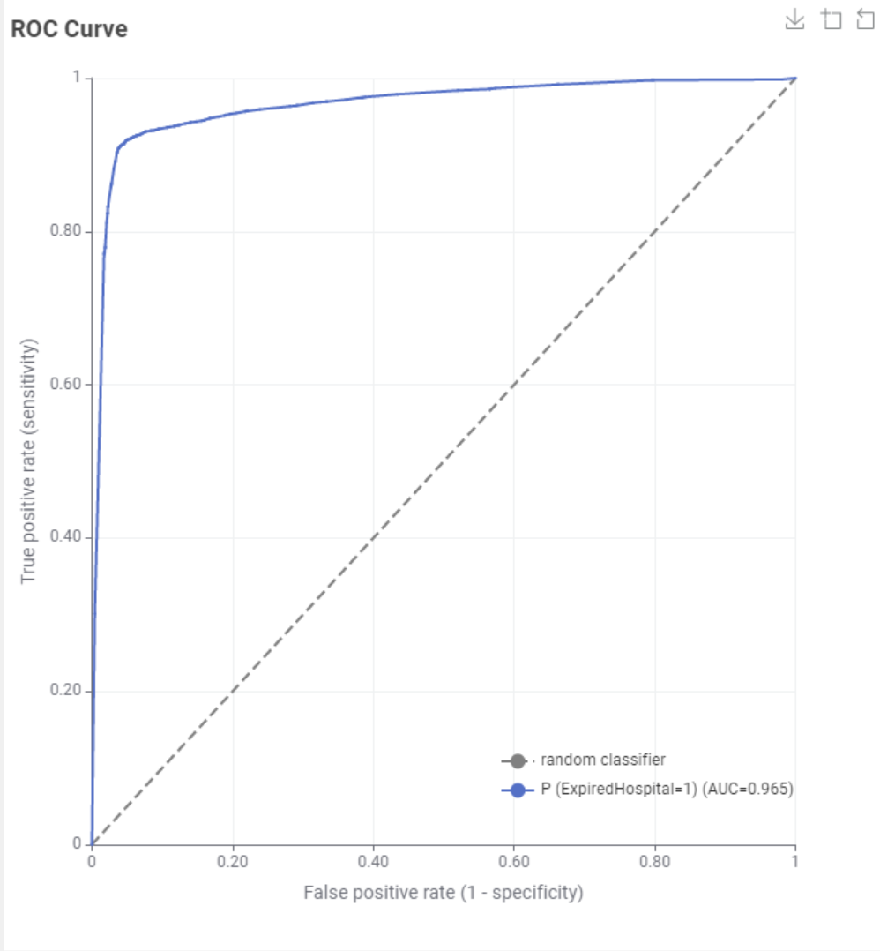

*Image 28 Model 2 ROC*

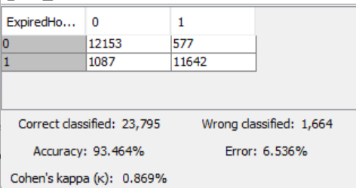

*Image 29 Model 2 Accuracy and Confusion Matrix*



*Image 30 Model 2 Scores*

### Model 3

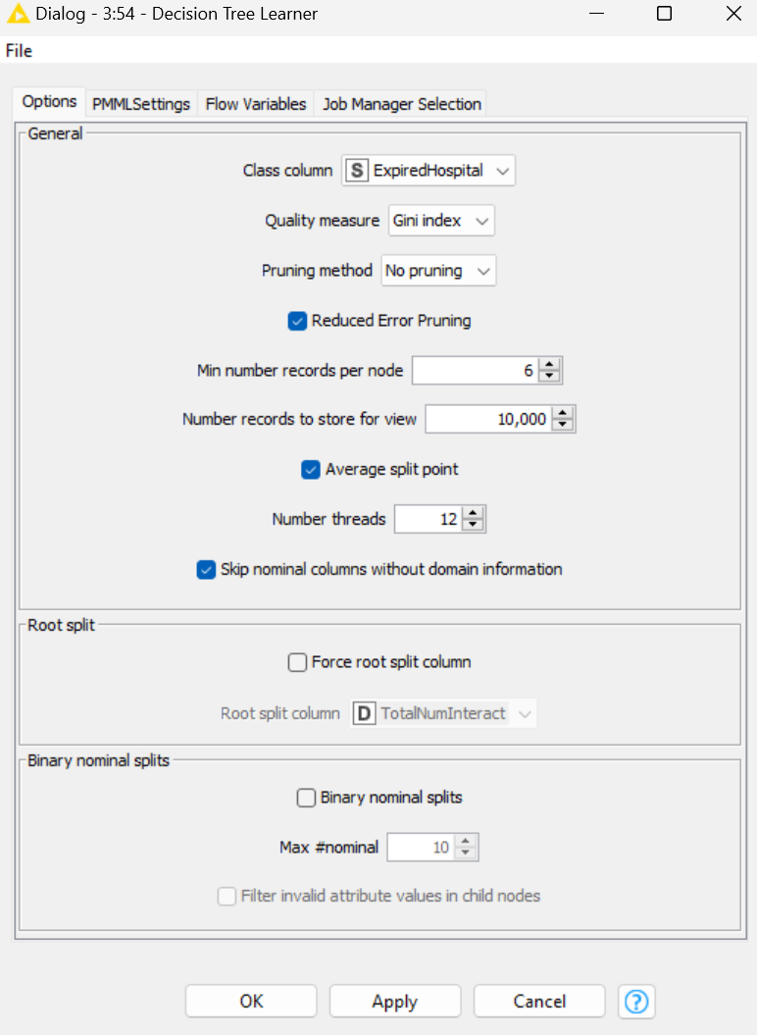

*Image 31 Model 3 Settings*

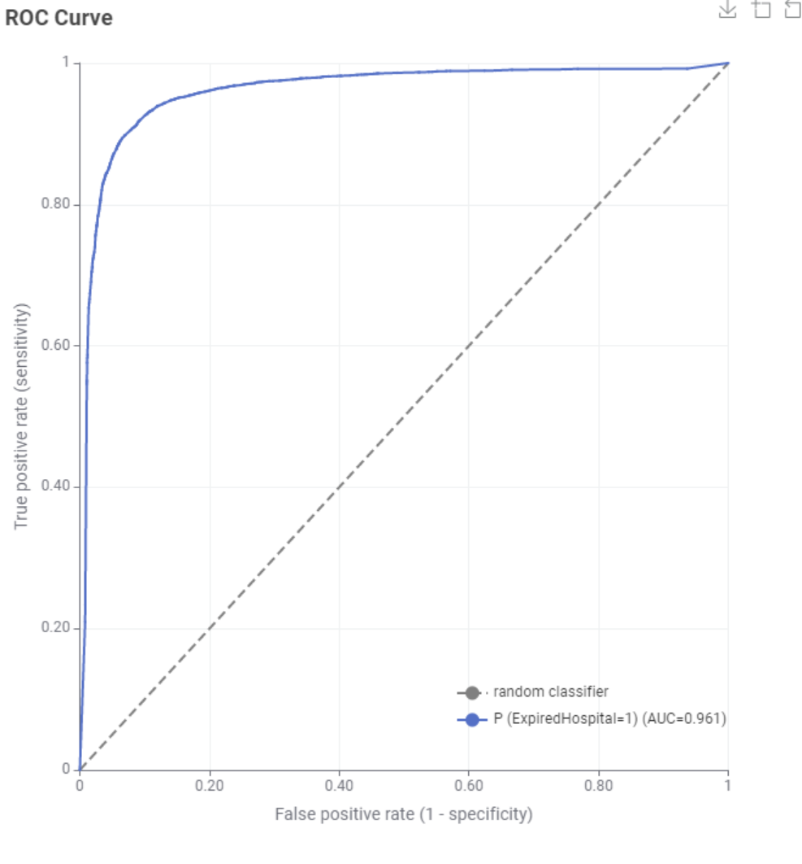

*Image 32 Model 3 ROC*

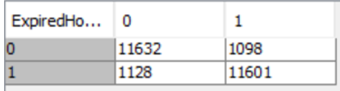

*Image 33 Model 3 Confusion Matrix*

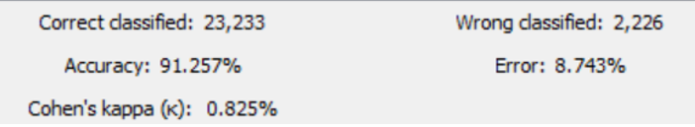

*Image 34 Model 3 Accuracy*



*Image 35 Model 3 Scores*

### Model 4

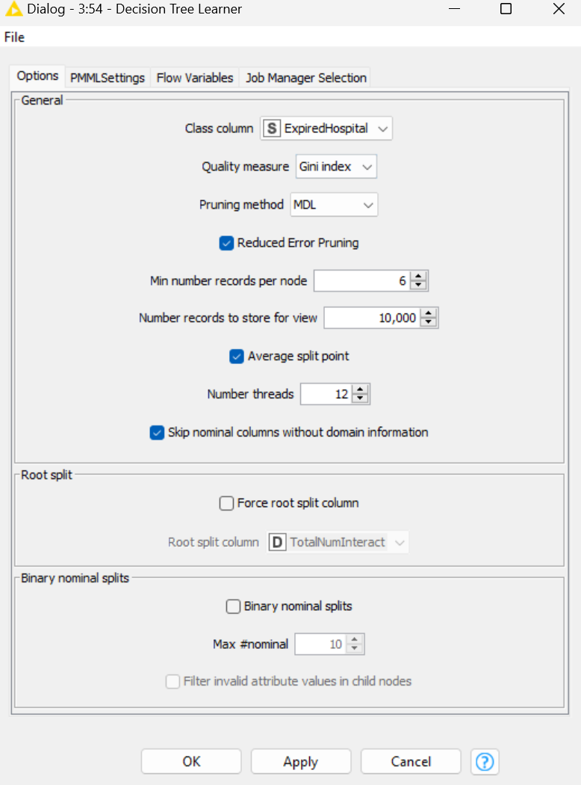

*Image 36 Model 4 Settings*

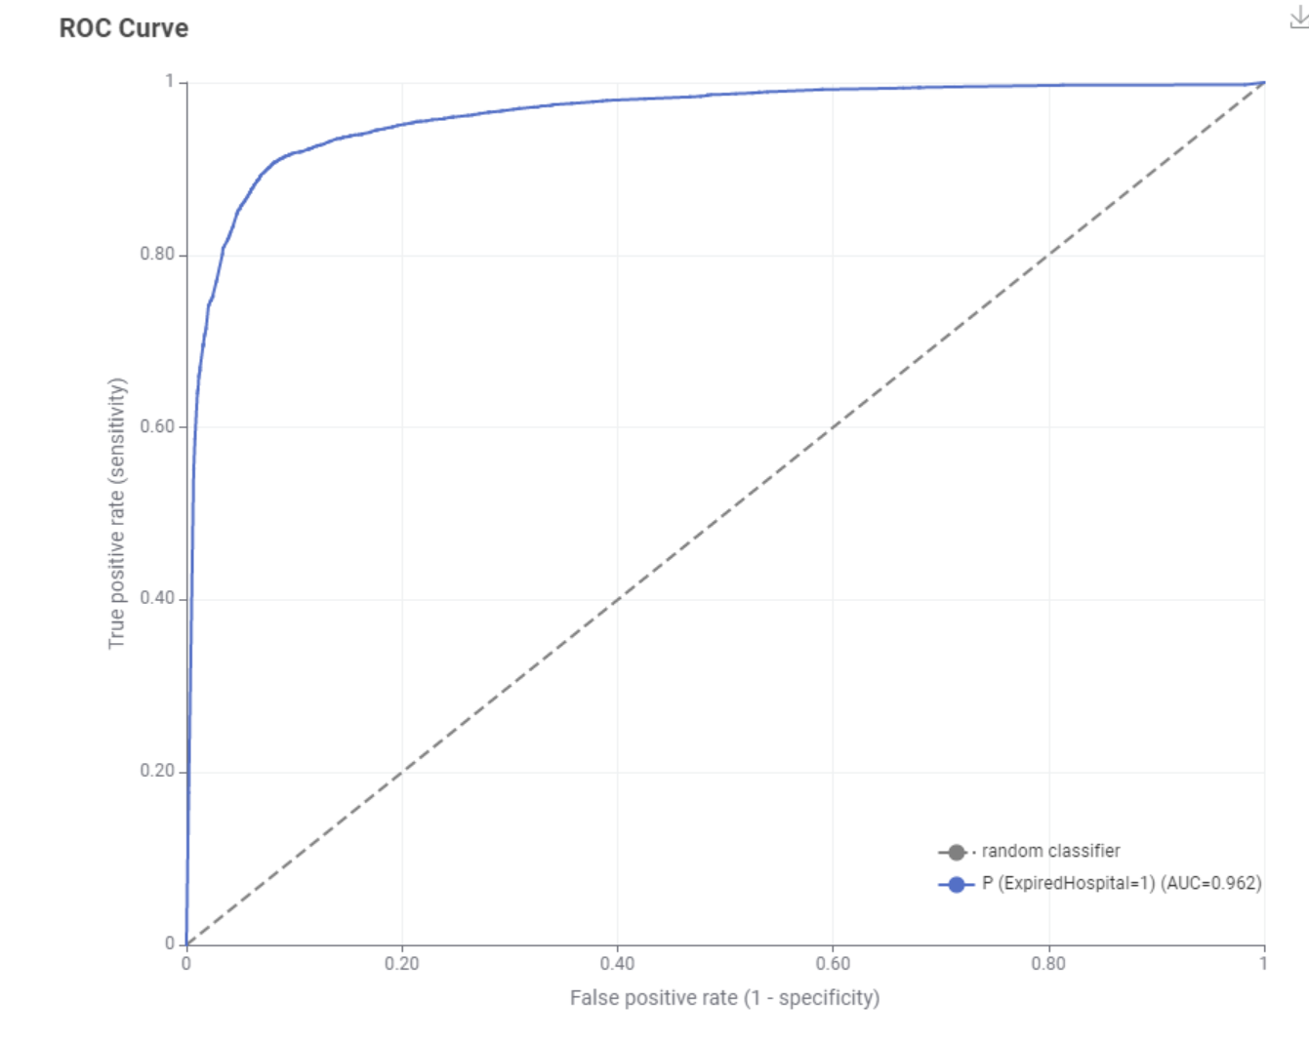

*Image 37 Model 4 ROC*

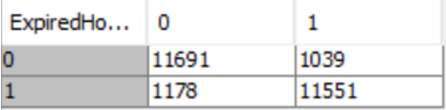

*Image 38 Model 4 Confusion Matrix*

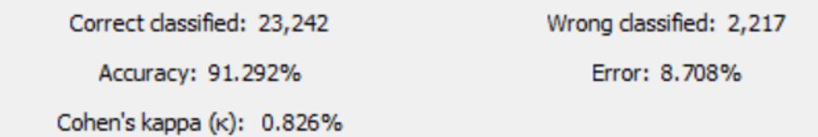

*Image 39 Model 4 Accuracy*



*Image 40 Model 4 Scores*

## K-Nearest Neighbour

K- Nearest Neighbour (KNN) compares the unknown class with the set of known classes based on the feature similarity or distance to the set of known classes it has available to it by majority vote. It is a instance-based algorithm.

Parameter optimisation was used to optimise the k value, i.e., the number of neighbours to consider (See Image 41). 2 was found to be the best value (See Image 42). In this case we send the test data into the model node too, and we don’t use a predictor node.

We found that KNN had an overall comparable AUC and higher accuracy than Decision Trees, however this came at the expense of a poorer true positive rate at lower false positive rates. From the confusion matrix we can visualise this and see that the model more frequently misclassifies negative cases to improve its accuracy in classifying positive cases. This indicates a poorer clarity of the model in differentiating the two classes, despite higher scores in Precision, Sensitivity and F-Measure.

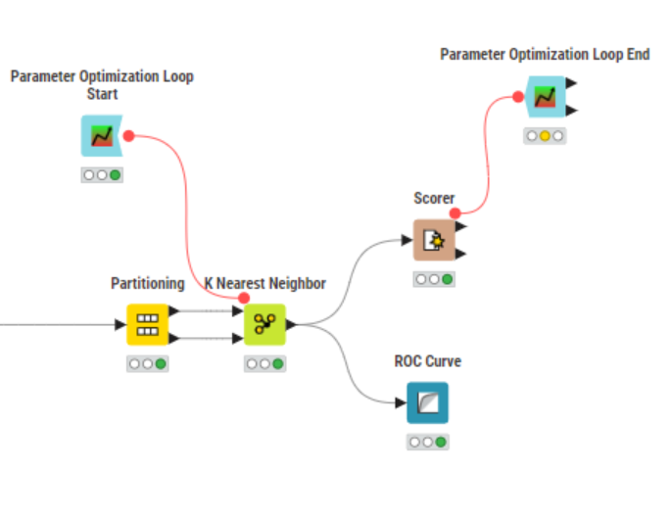

*Image 41 KNN Workflow*

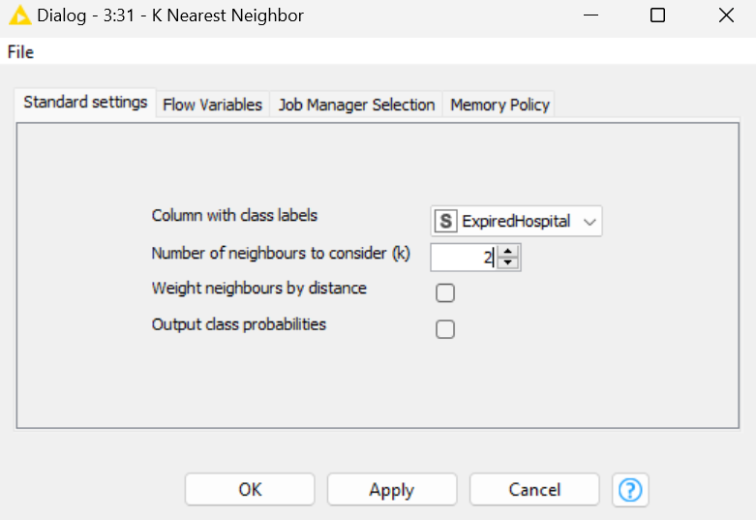

*Image 42 KNN Settings*

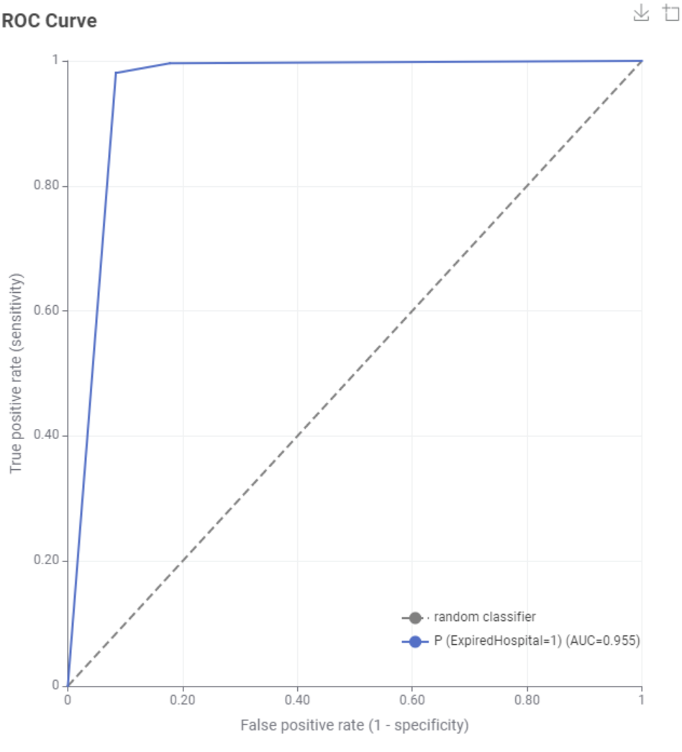

*Image 43 KNN ROC*

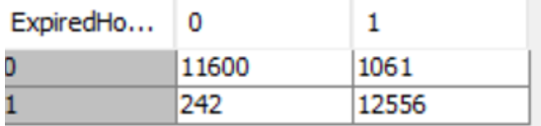

*Image 44 KNN Confusion Matrix*

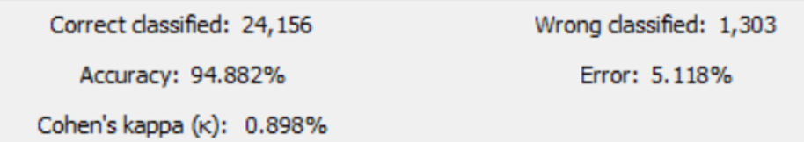

*Image 45 KNN Accuracy*



*Image 46 KNN Scores*

## Random Forest (Ensemble Method)

Random forest is an ensemble method for decision trees which uses bootstrap sampling. This involves drawing of sample data repeatedly with replacement from the test set to estimate a population parameter. This creates a random forest of N decision trees which helps to avoid overfitting and improves the stability of machine learning algorithms after we compare each decision tree.

We found setting the number of decision tree models to an industry standard value of 100 was sufficient to maximise the accuracy of the classifier while minimising training time. We tested each split criterion method to find the best value. We included all attributes as preprocessing was already done to remove useless attributes, which will ultimately generalise our classifiers.

We found that the split criterion had a minimal affect on the performance of the model. Interestingly, the AUC values were identical amongst the different models. Similarly, the values from the scoring node are comparable between the models, however model 1 showed marginally better performance than the other two models when considering accuracy and the related measures.

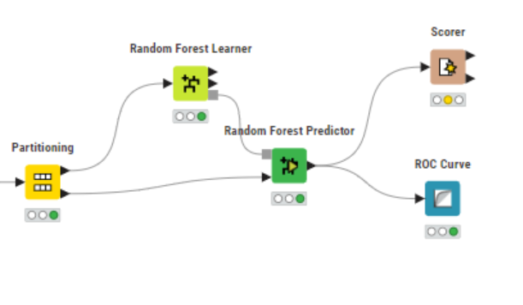

*Image 47 RF Workflow*

### Model 1

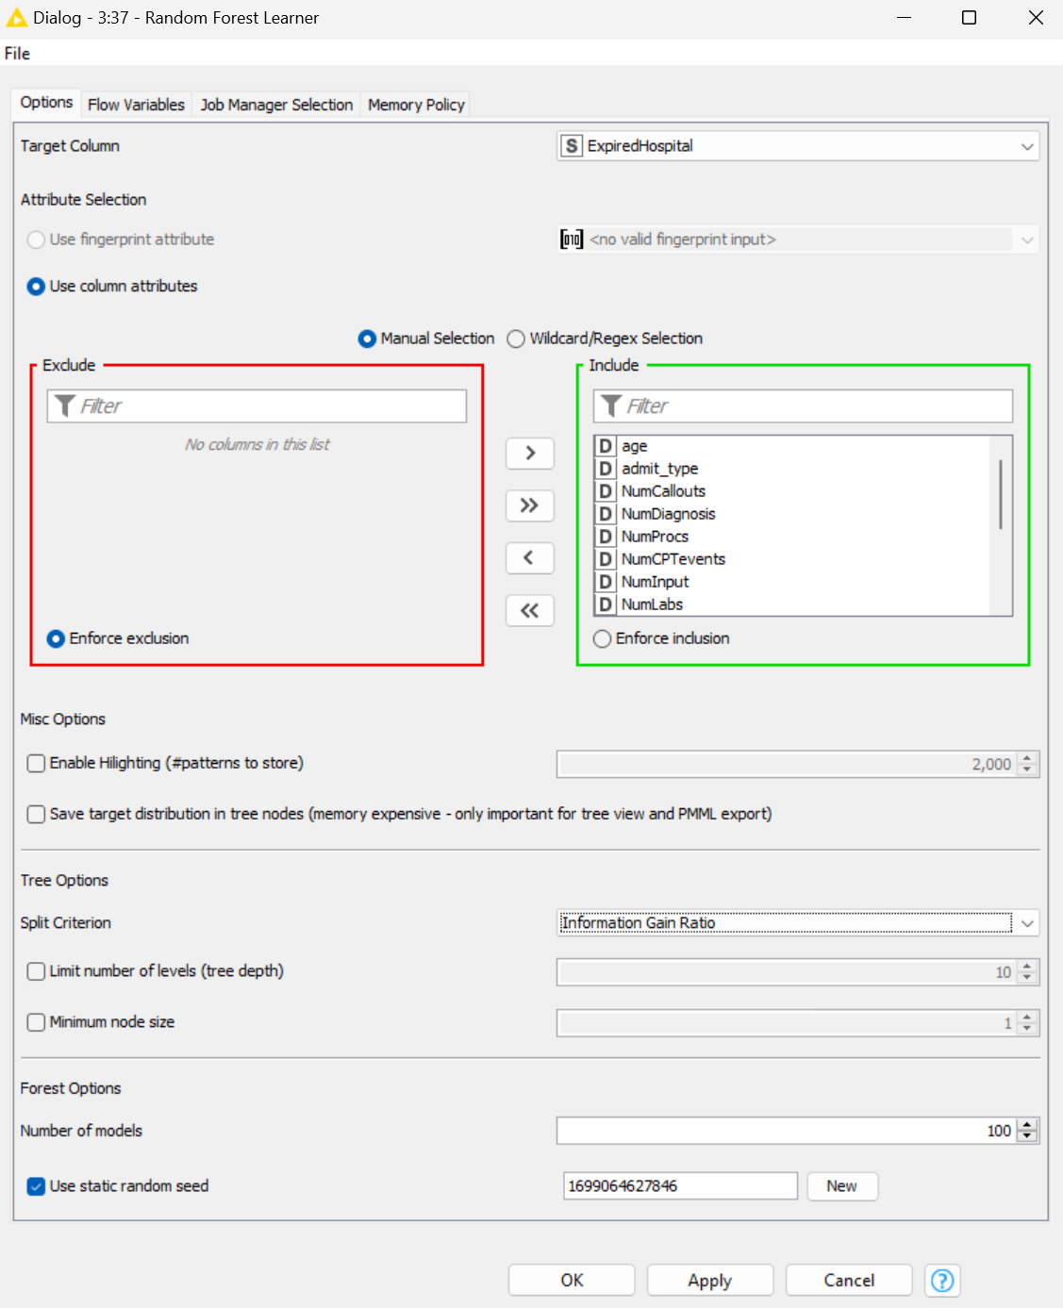

*Image 48 Model 1 Settings*

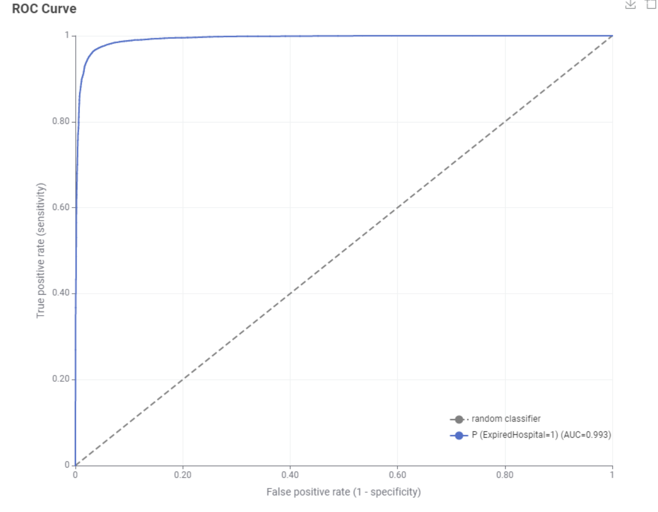

*Image 49 Model 1 ROC*

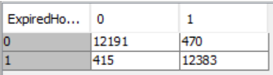

*Image 50 Model 1 Confusion Matrix*

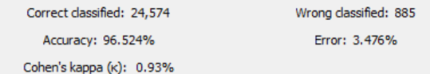

*Image 51 Model 1 Accuracy*



*Image 52 Model 1 Scores*

### Model 2

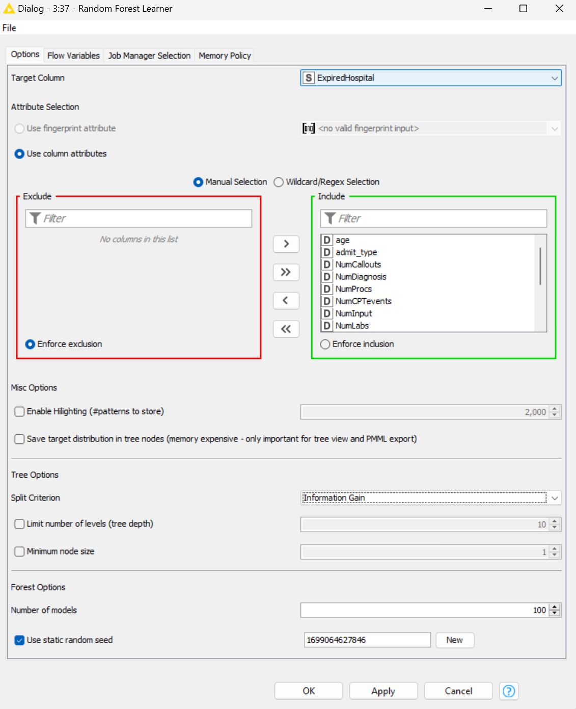

*Image 53 Model 2 Settings*

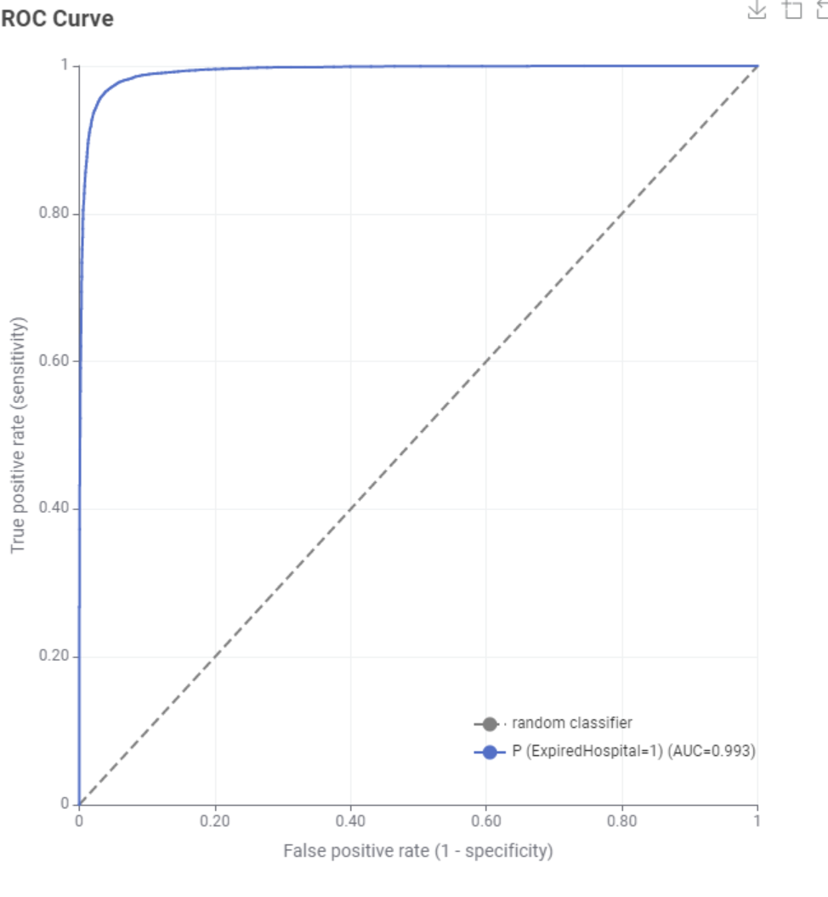

*Image 54 Model 2 ROC*

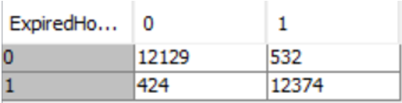

*Image 55 Model 2 Confusion Matrix*

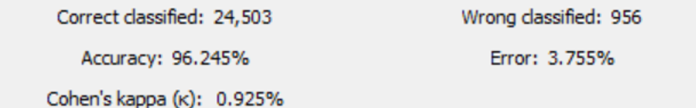

*Image 56 Model 2 Accuracy*

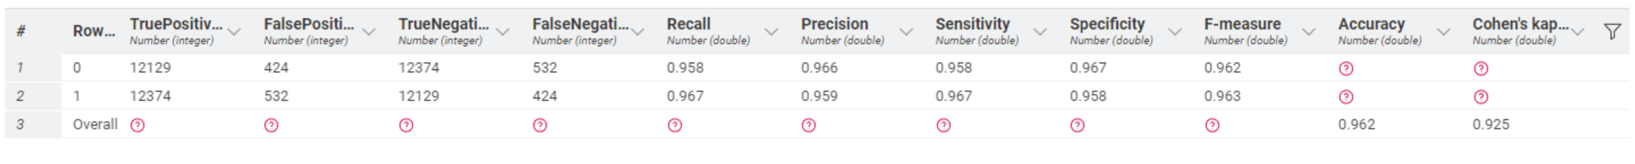

*Image 57 Model 2 Scores*

### Model 3

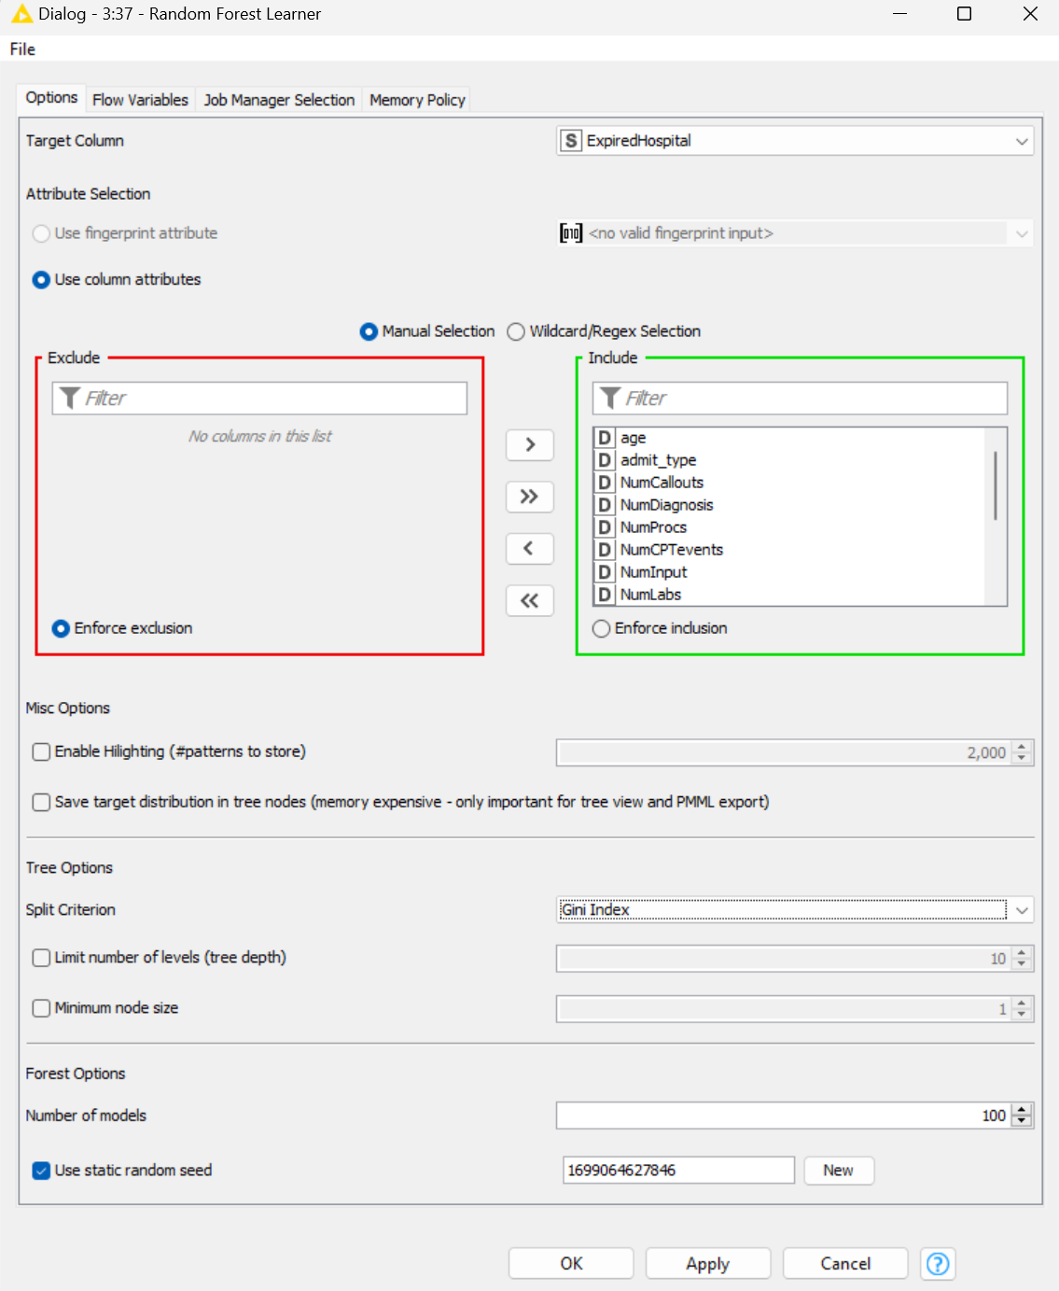

*Image 58 Model 3 Scores*

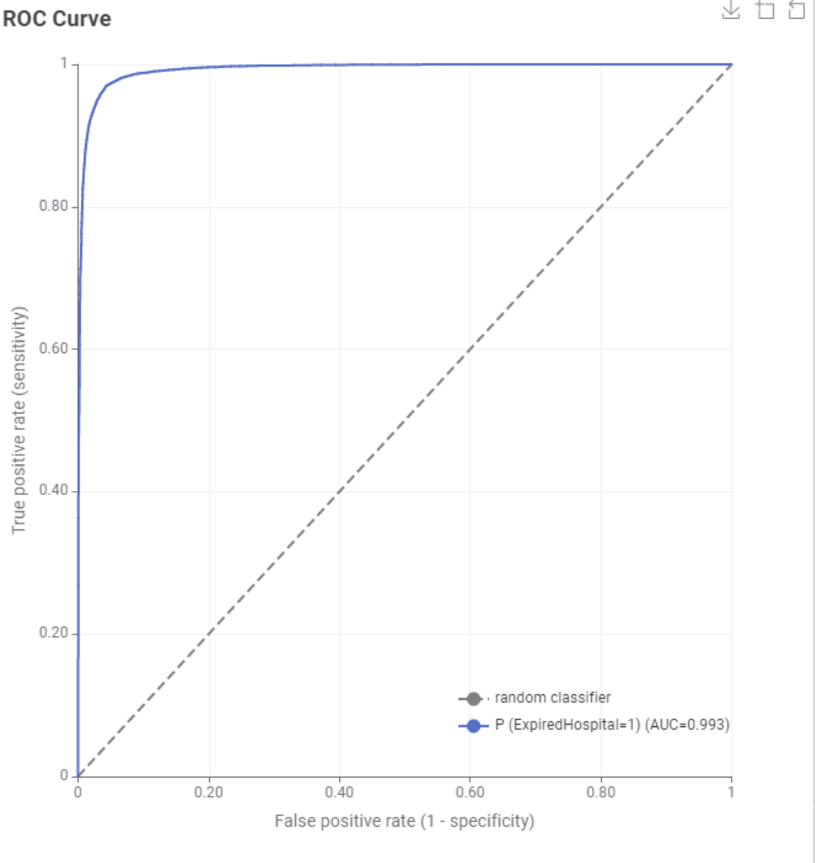

*Image 59 Model 3 ROC*

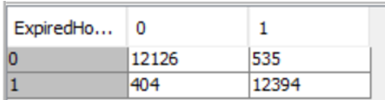

*Image 60 Model 3 Confusion Matrix*

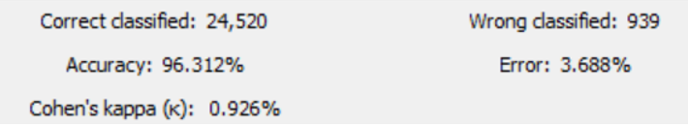

*Image 61 Model 3 Accuracy*



*Image 62 Model 3 Scores*

## Support Vector Machine

Support Vector Machines (SVMs) are a supervised learning model that analyse data used for classification and regression analysis. It requires a labelled dataset, so it is appropriate to this problem. An SVM finds the optimal separating hyperplane of training data points which maximises the margin between these points and the separating line.

There are several Kernal parameter options. We found RBF to be the most accurate compared to the polynomial and hyper tangent options, which is also supported by academic literature on the model. Using parameter optimisation, we found 0.3 to be the best sigma value for the SVM (See Images 63 and 64). We tested values between 0.1 and 2 with step sizes of 0.1. We modified the partitioning node in this case to use 20/80 split for the training and test data sets respectively. This is because SVM’s are computationally intensive to train, and we did not have the compute power to maintain the 70/30 split in the time frame required. 20% is a recommended value in such cases which still captures as much of the majority trends in the training data as possible while minimising training time.

We found this mode performed the poorest, most likely due to the limited training data compared to other models. The AUC is adequate at 81%, however the accuracy is very poor due to the high false negative rate. The model is one of the most accurate when it comes to negative cases, however, it is not robust enough to categorise positive cases accurately, possibly due to bias towards the negative case in the data set.

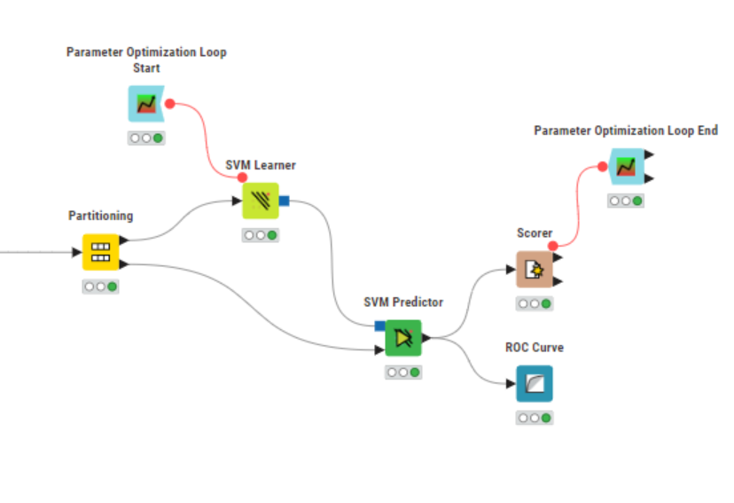

*Image 63 SVM Workflow*

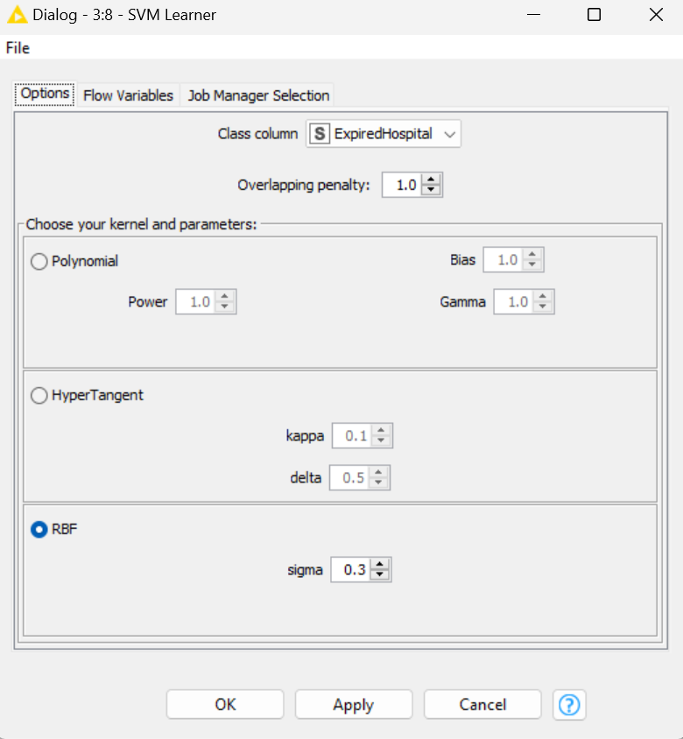

*Image 64 SVM Settings*

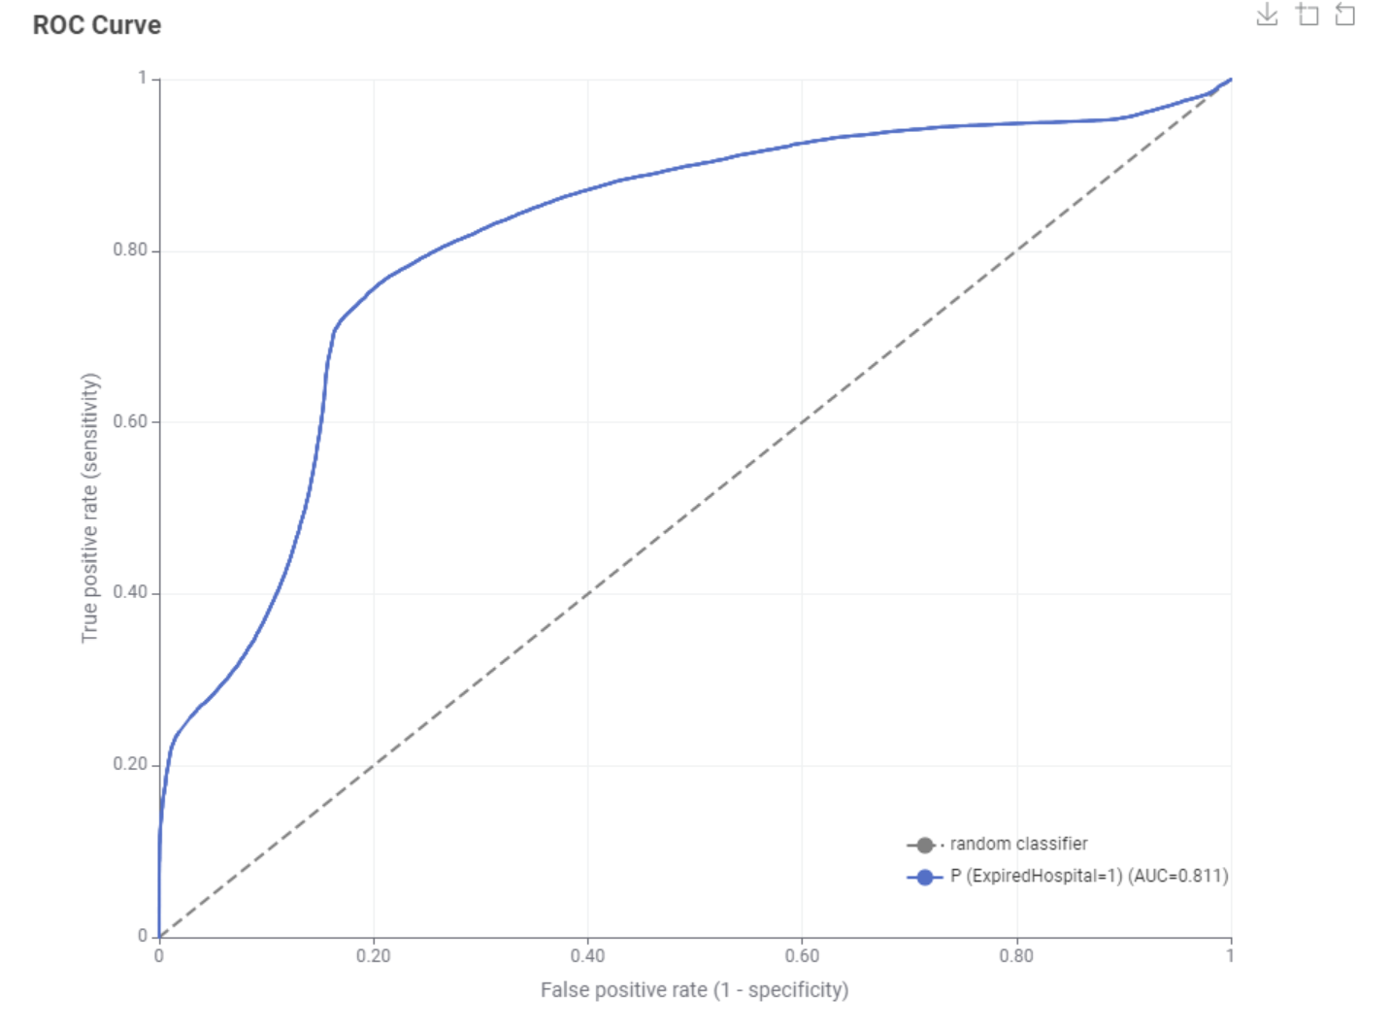 *Image 65 SVM ROC*

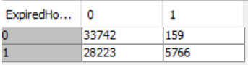

*Image 66 SVM Confusion Matrix*

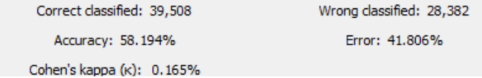

*Image 67 SVM Accuracy*



*Image 68 SVM Scores*

## Multi-Layer Perceptron (Neural Network)

Multi-layer perceptron (MLP) classifiers are a neural network model which can find complex relationships in datasets between many variables at a time. This is achieved by an interconnected network of neurons. 100 iterations were found to be sufficient to maximise the accuracy of the model, and is a valid as it is an industry standard value. We used parameter optimisation on the “Hidden Neurons Per Layer” and “Hidden Layers” parameters within the integer ranges of 1-30 and 1-10 respectively. 5 and 3 were the optimal values respectively (See Images 69 and 70)

The MLP had a reasonable performance with an AUC 0.921 however it was still tangibly lower and less effective than other classifiers such as random forest. Similarly, the accuracy measures hover around 85%. However, the classifier is approximately equal at classifying both classes as demonstrated by the confusion matrix which indicates a lack of bias, unlike previous models.

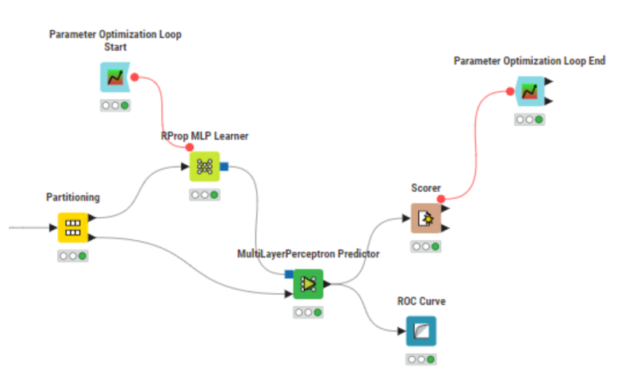

*Image 69 MLP Workflow*

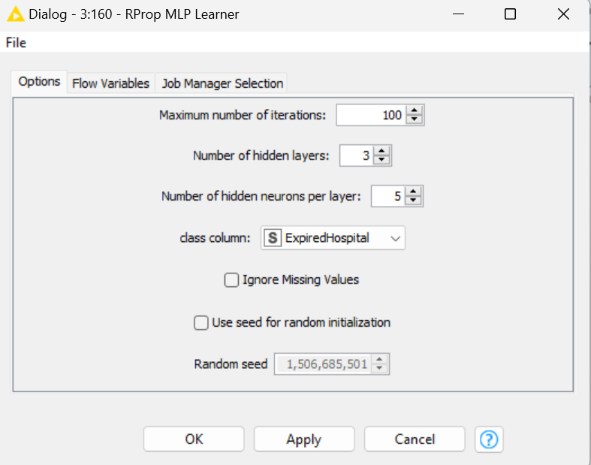

*Image 70 MLP Settings*

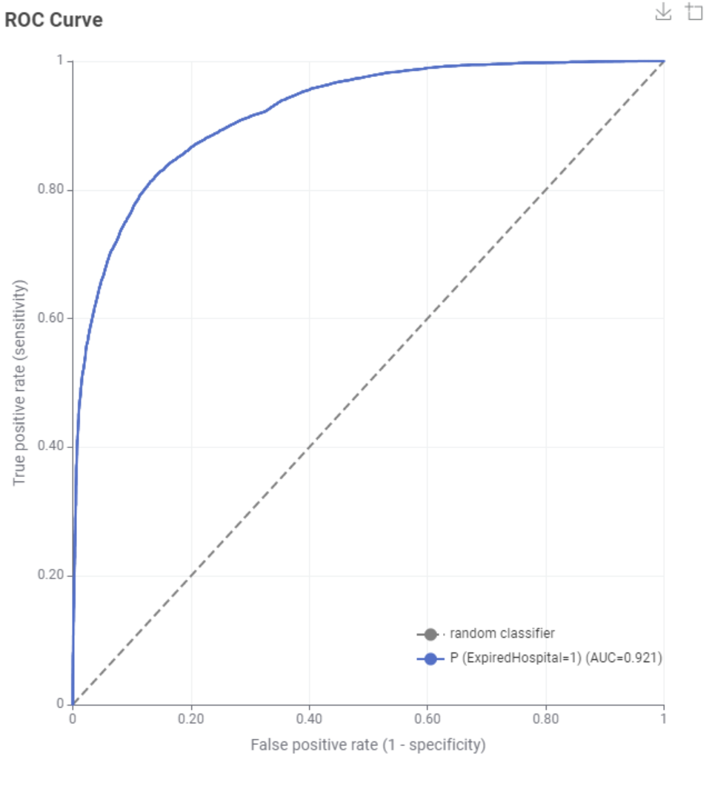

*Image 71 MLP ROC*

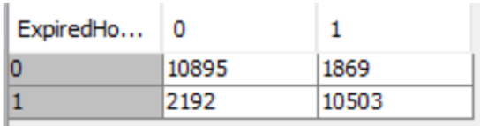

*Image 72 MLP Confusion Matrix*

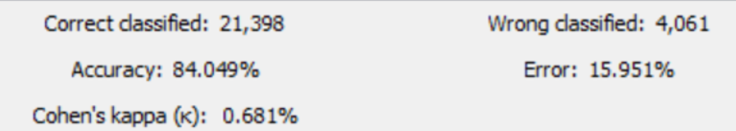

*Image 73 MLP Accuracy*

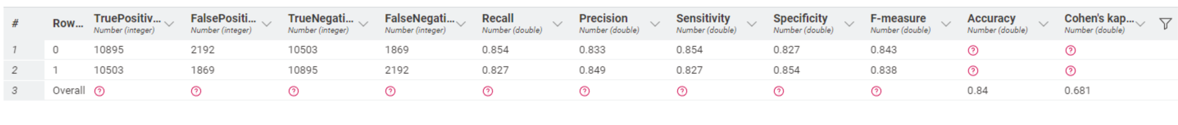

*Image 74 MLP Scores*

## Gradient Boosted Trees Learner (Ensemble Method)

A gradient boosted trees learner uses shallow trees with a special form of boosting to develop an ensemble of trees. We used parameter optimisation to find the optimal values for the tree depth, number of models and learning rate parameters between 0 and 100 with increments of 0.1. We found 10, 100 and 0.1 respectively produced the best performance. All attributes were included as irrelevant attributes were already removed during preprocessing (See Images 75 and 76).

This classifier was the second most effective after Random Forest models, this is demonstrated by the symmetrical ROC curve with an AUC of 0.980. The accuracy scores are all symmetrical for the positive and negative cases indicating a very unbiased classifier.

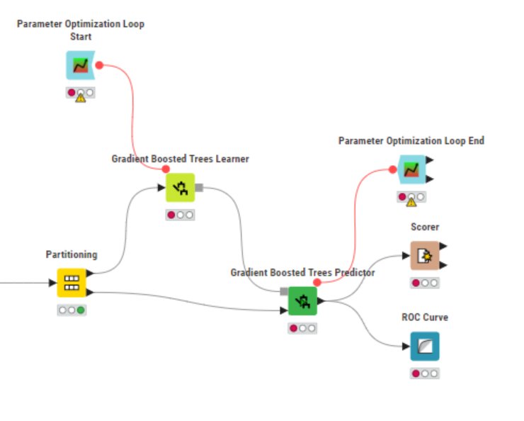

*Image 75 GBT Workflow*

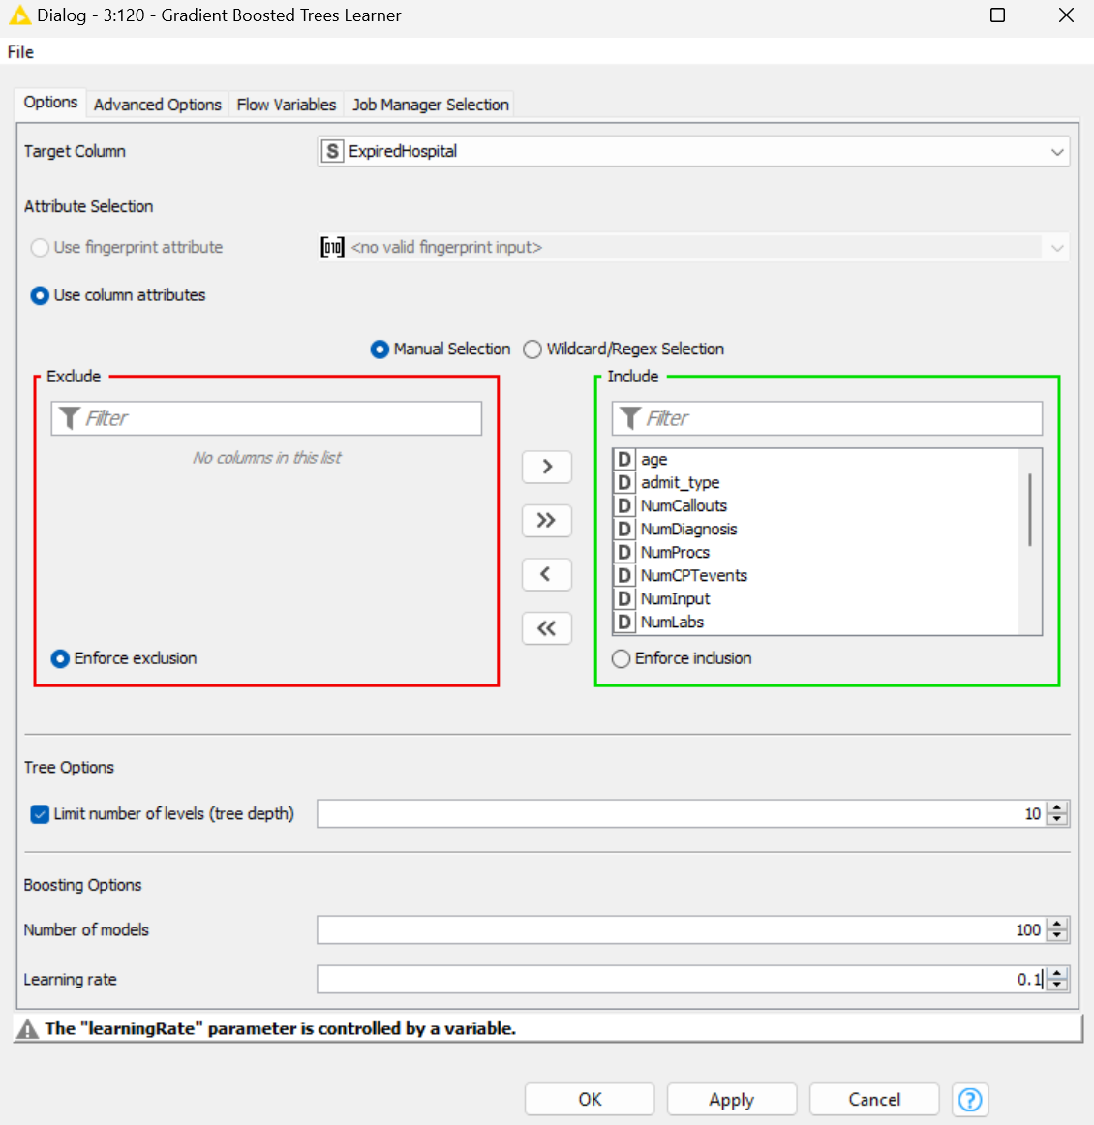

*Image 76 GBT Settings*

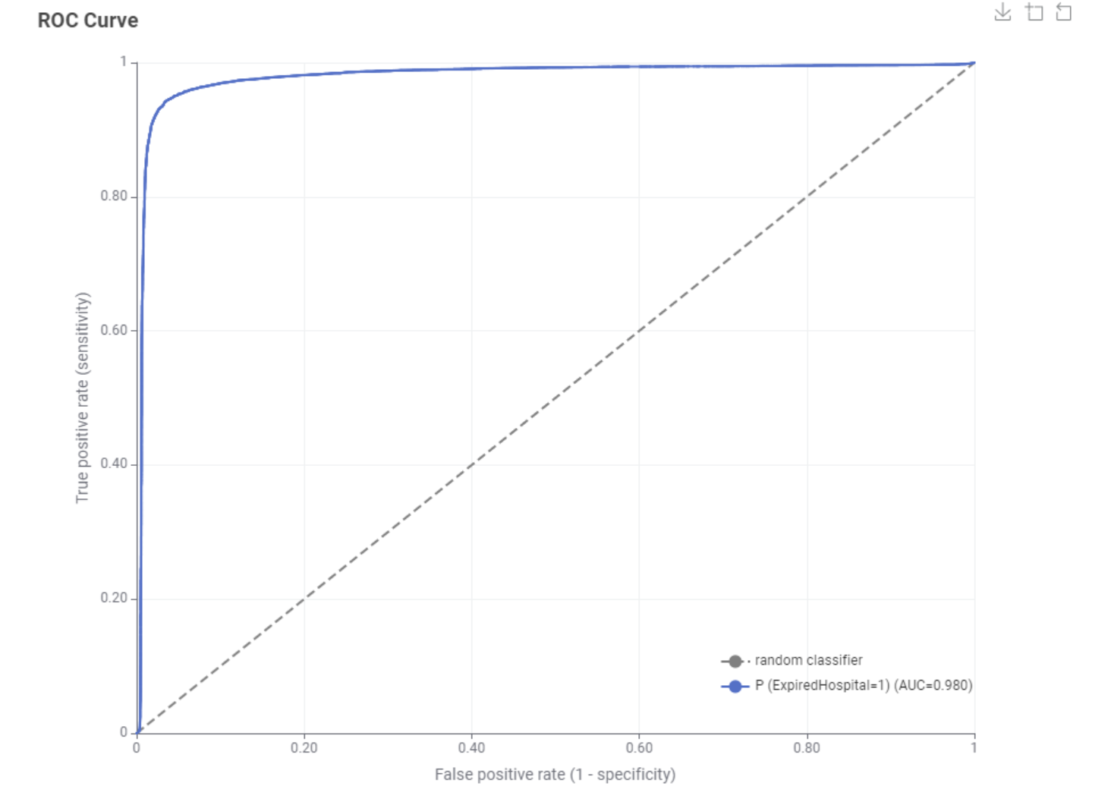

*Image 77 GBT ROC*

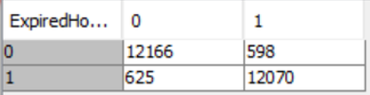

*Image 78 GBT Confusion Matrix*

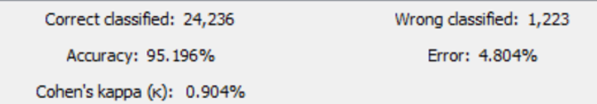

*Image 79 GBT Accuracy*

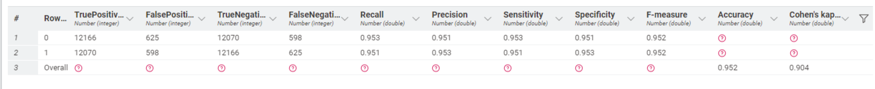

*Image 80 GBT Scores*

## K Fold Cross Validation on KNN

K fold cross validation helps us to evaluate the quality of a model and avoid overfitting and underfitting. We randomly divide the data into k folds with the X-Partitioner node. Each fold has approximately the same number of records, then we create k models using the same algorithm and training parameters. We test on the last fold, where accuracy is the average of the k accuracies. We use K = 10 which is a standardised effective value. We found the number of neighbours to consider to be optimised at 2. (See Images 81 and 82).

This model achieved relatively high performance, however the performance was strongly affected by positive and negative cases. Interestingly, the AUC was high at 0.96, with a similar accuracy of approximately 93%. However, the confusion matrix indicates a high disparity between the model’s poorer ability to classify the negative case versus the positive case. This was the opposite of how the other models were biased.

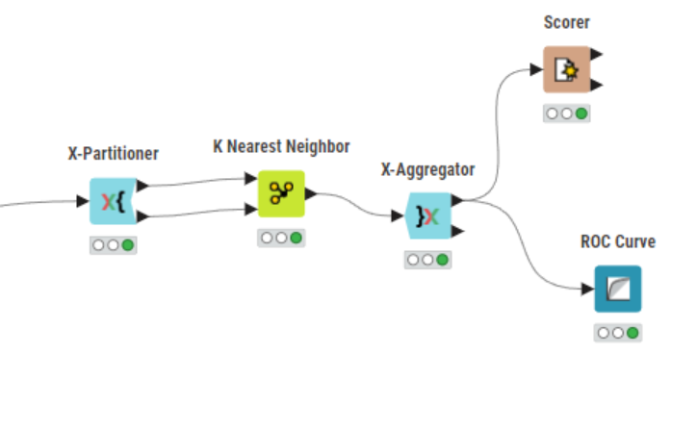

*Image 81 KF KNN Workflow*



*Image 82 KF KNN Settings*

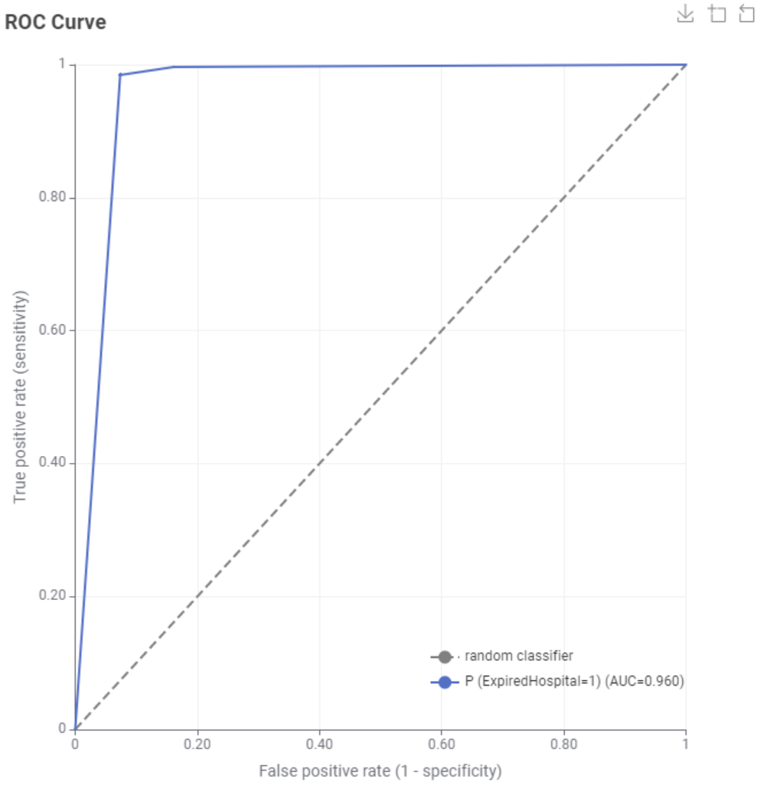

*Image 83 KF KNN ROC*

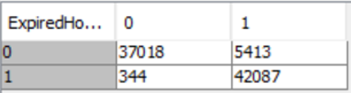

*Image 84 KF KNN Confusion Matrix*

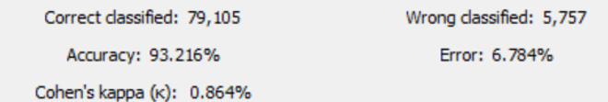

*Image 85 KF KNN Accuracy*



*Image 86 KF KNN Scores*

# Selected Classifier

Below we provide the evaluation metrics used for the best performing model of each type. For measures specific to categories, we average the value across the categories. We find that RF performs best across all metrics and hence this was the classifier chosen (Table 3). The selected model used Information Gain Ratio as our split criterion, with 100 models and all attributes after preprocessing. This model also produced the highest score on Kaggle. This model performs well as it is an ensemble method that harnesses trends learned from multiple models to avoid overfitting and maximise accuracy for both categories. Further, as each feature doesn’t consider all properties we reduce the classification time of the model, as well as the training time for efficiency. To maximise accuracy of the model on unseen data the same preprocessing (Column Filtering and Normalisation) should be applied. The model writer node was used to export this classifier.

|  |  |  |  |  |  |  |  |  |
| --- | --- | --- | --- | --- | --- | --- | --- | --- |
| *Model* | *Acc* | *Cohen’s Kappa* | *AUC* | *Recall* | *Precision* | *Sensitivity* | *Specificity* | *F-Measure* |
| DT | 93.35% | 0.867 | 0.974 | 0.9335 | 0.934 | 0.9335 | 0.9335 | 0.9335 |
| KNN | 94.88% | 0.898 | 0.955 | 0.9485 | 0.951 | 0.9485 | 0.9485 | 0.9485 |
| RF | 96.52% | 0.93 | 0.993 | 0.9655 | 0.9655 | 0.9655 | 0.9655 | 0.965 |
| SVM | 58.19% | 0.165 | 0.811 | 0.5825 | 0.759 | 0.5825 | 0.5825 | 0.4965 |
| MLP | 84.05% | 0.681 | 0.921 | 0.8405 | 0.841 | 0.8045 | 0.8405 | 0.8405 |
| GBT | 95.20% | 0.904 | 0.980 | 0.952 | 0.952 | 0.952 | 0.952 | 0.952 |
| KF KNN | 93.225 | 0.864 | 0.960 | 0.932 | 0.9385 | 0.932 | 0.932 | 0.932 |

*Table 3 Model Scores*

# Kaggle Submission Score

The selected RF model placed 33rd with a score of 0.81887.



*Image 87 Kaggle Submission*

# Summary

To summarise, we processed the training data with rank correlation column filtering, number to string conversion, missing value filling and normalisation. This resulted in more robust and accurate models. We evaluated the models based on the ROC curve, the AUC and accuracy measures from the scoring node. The worst model produced was SVM due to a lack of training time. The best mode was RF with information grain ratio and 1000 models. This produced notably higher accuracy scores than other models. This resulted in a strong placing in the Kaggle competition, however DT and GBT models would have performed similarly. Future options for exploration include training the SVM model on better hardware to enable the best possible performance of the model to be found. Additionally, other ensemble methods like combining different classifiers based on their relative strengths could show even better performance. RF performed the best due to its resistance to overfitting, indicating that the training data does have some noise which should be considered for the approach to future model development.

# Appendix

*Appendix 1: Knime Workflow*

